“Passenger Name Record (PNR) Manager”
A Project Report Submitted in the partial fulfillment of the requirements for the award of the degree of

BACHELOR OF TECHNOLOGY
In
DEPARTMENT OF COMPUTER SCIENCE ENGINNERING
By
BHANU JAKKA | :2520030006
HAVISHAA REDDY | :2520030371
Under the Esteemed Guidance of
D PAVITHRA
Assistant Professor

Department of Computer Science and Engineering


K L (Deemed to be) University DEPARTMENT OF COMPUTER SCIENCE ENGINEERING



Declaration

The Project Report entitled “Passenger Name Record (PNR) Manager” is a record of Bonafide work of BHANU JAKKA – 2520030006 , HAVISHAA REDDY – 2520030371 submitted in partial fulfillment for the award of B. Tech in Computer Science and Engineering to the K L University. The results embodied in this report have not been copied from any other departments/University/Institute.

BHANU JAKKA – 2520030006
HAVISHAA REDDY - 2520030371

K L (Deemed to be) University
DEPARTMENT OF COMPUTER SCIENCE ENGINEERING



CERTIFICATE
This is certify that the mini project based report entitled “Passenger Name Record (PNR) Manager” is a bonafide work done and submitted by BHANU JAKKA – 2520030006, HAVISHAA REDDY – 2520030371 in partial fulfillment of the requirements for the award of the degree of BACHELOR OF TECHNOLOGY in Department of Computer Science Engineering, K L (Deemed to be University), during the academic year 2025-2026.

Signature of the Guide
Signature of the Course Coordinator Signature of the HOD

ACKNOWLEDGEMENT

The success in this project would not have been possible but for the timely help and guidance rendered by many people. Our wish to express my sincere thanks to all those who has assisted us in one way or the other for the completion of my project.
Our greatest appreciation to my Course Coordinator D. PAVITHRA, and my guide D. PAVITHRA, Department of Computer Science which cannot be expressed in words for his/her tremendous support, encouragement and guidance for this project.
We express our gratitude to Dr. N Chaintanya Kumar Head of the Department for Computer Science Engineering for providing us with adequate facilities, ways and means by which we are able to complete this project-based Lab.
We thank all the members of teaching and non-teaching staff members, and also who have assisted me directly or indirectly for successful completion of this project. Finally, I sincerely thank my parents, friends and classmates for their kind help and cooperation during my work.

BHANU JAKKA – 2520030006
HAVISHAA REDDY - 2520030371

Abstract
The Passenger Name Record (PNR) Manager is a web-based application developed to simplify and streamline the management of airline booking records. A PNR is a unique 6-digit alphanumeric code assigned to each passenger’s booking, which acts as a reference to access complete travel information. It stores essential details such as passenger information, flight itinerary, seat allocation, and Special Service Requests (SSR) like meal preferences or special assistance. Efficient management of PNR data is crucial for airline operations, as it directly impacts service quality and operational accuracy.

This system provides a centralized platform where users can easily search, view, modify, and cancel PNR records. The search functionality enables quick retrieval of booking details using the PNR code or passenger-related information. The detailed view displays all relevant data in a structured format, allowing users to clearly understand and manage bookings. The modify and cancel features provide flexibility in handling changes, while SSR management ensures that specific passenger requirements are properly addressed.

A key feature of the system is the audit trail, which records every action performed on a PNR, including updates and cancellations. This enhances transparency, accountability, and system monitoring. Additional features such as notifications, history tracking, and data export further improve usability and functionality.

The PNR Manager is built using modern web technologies, offering a responsive and user-friendly interface. By automating and centralizing booking operations, the system minimizes manual errors, saves time, and increases efficiency. Overall, it provides a reliable and structured solution for managing airline reservation data effectively.

Index
S.  No. | Chapters | Topics | Page.no
 |  | Acknowledgement
 |  | Abstract
1 | Introduction | 1.1 Background of the project  1.2 Problem statement  1.3 Scope of the project  1.4 Objective(s)  1.5 Importance of the application  1.6 Target users/audience | 5-10
2 | System Requirements | 2.1 Hardware requirements  2.2 Software requirements  2.3 Development tools and frameworks | 11-14
3 | Technology Stack | 3.1 Front-end (e.g., React.js, Angular, HTML/CSS)  3.2 Back-end (e.g., Node.js, Django, Spring Boot)  3.3 Database (e.g., MongoDB, MySQL, PostgreSQL)  3.4 Version Control (e.g., Git, GitHub)  3.5 APIs or External services (e.g., Firebase, Stripe) | 15-22
4 | System Architecture | 4.1 High-level architecture diagram  4.2 Description of each layer (frontend, backend, database)  4.3 Deployment architecture (e.g., cloud, local, CI/CD pipelines) | 23-27
5 | Design | 5.1 ER Diagram / Database schema | 28
6 | Implementation | 6.1 Module-wise implementation  6.2 Front-end logic (UI rendering, state management)  6.3 API integration  6.4 Authentication & Authorization | 39-40
7 | Features | 7.1 List of main features  7.2 How each feature works (user perspective + technical description) | 41-45
8 | Testing | 8.1 Postman testing (frontend/backend)  8.2 Integration testing  8.3 Tools used for testing  8.4 Test cases and results | 46-55
9 | Deployment | 9.1 Steps to deploy  9.2 Environment configuration  9.3 Hosting of frontend and backend | 56-65
10 | Challenges &  Limitations | 10.1 Issues faced during development  10.2 Solutions applied  10.3 Current limitations or known bugs | 66-72
11 | Future Enhancements | 11.1 Planned features  11.2 Possible integrations or optimizations | 73-76
12 | Conclusion | 12.1 Summary of the project  12.2 What was achieved  12.3 Skills learned during development | 77-85
13 | References | - Books, tutorials, APIs, documentation sites used | 86-87

14 | Appendices | - Screenshots of the app  - Sample code snippets  - Installation/setup instructions  - User manual or guide | 88-96

CHAPTER -1 INTRODUCTION

1.1 Background of the Project

Air travel has evolved into one of the most critical infrastructures of modern society, connecting people, cultures, and economies across the globe. At the heart of this system lies the Passenger Name Record (PNR), a unique identifier that encapsulates all essential details of a passenger’s journey. From the moment a ticket is booked, the PNR becomes the digital footprint of the traveler, storing information such as flight schedules, seat assignments, and special service requests. Historically, these records were managed through legacy reservation systems that were often rigid, text-based, and designed primarily for airline staff rather than passengers.
As the aviation industry expanded, these systems struggled to keep pace with the growing complexity of passenger needs. The rise of low-cost carriers, international travel, and diverse passenger demographics introduced new challenges. Passengers began to expect flexibility, transparency, and control over their bookings, while airlines sought efficiency, accountability, and compliance with international standards. The background of this project is rooted in this tension: the need to modernize PNR management so that it serves both passengers and airlines effectively.
The digital revolution further amplified these expectations. With smartphones, cloud computing, and web applications becoming ubiquitous, passengers now demand instant access to their booking details, the ability to make modifications without lengthy procedures, and clear communication from airlines. Airlines, in turn, require systems that minimize errors, reduce operational bottlenecks, and provide actionable insights through data analytics. This project emerges as a response to these evolving needs, aiming to design a web-based PNR management system that integrates modern technology with passenger-centric service delivery.
By situating itself within the broader historical and technological context, the project acknowledges the limitations of traditional systems while embracing the opportunities offered by digital innovation. It is not merely a technical exercise but a service-oriented initiative that seeks to redefine how passengers interact with their bookings and how airlines manage their operations. The background therefore establishes the foundation for a project that is both timely and transformative.

1.2 Problem Statement
Despite significant advancements in airline reservation systems, several persistent issues continue to undermine the passenger experience and airline efficiency. One of the most pressing problems is the lack of flexibility in modifying or canceling bookings. Passengers often encounter confusing procedures, long wait times, or even financial penalties when attempting to make changes. This not only frustrates travelers but also erodes trust in the airline’s ability to provide customer-friendly services.
Another critical issue is the inadequate handling of Special Service Requests (SSR). Passengers with specific needs—such as dietary preferences, wheelchair assistance, or medical requirements—often find that existing systems do not adequately support these requests. Airline staff may struggle to record, track, and fulfill such requirements, leading to service gaps and dissatisfaction among passengers who rely on these accommodations.
Transparency is another area where current systems fall short. When bookings are modified or canceled, passengers rarely receive a clear record of what changes were made, who made them, and when. This lack of accountability can result in disputes, errors, and mistrust. Airlines, too, face challenges in maintaining reliable records, which can affect compliance with regulatory standards and damage their reputation.
The absence of timely notifications and accessible booking histories further compounds the problem. Passengers often remain uncertain about the status of their travel plans, leading to anxiety and confusion. For airlines, the sheer scale of operations means that even minor inefficiencies can escalate into significant bottlenecks. With millions of PNRs generated daily, the inability to manage them effectively can result in operational delays, increased costs, and reduced customer loyalty.
The problem statement thus highlights the urgent need for a modern application that addresses these gaps. By offering efficient modification workflows, SSR integration, transparent audit trails, and enhanced passenger communication, the project seeks to resolve the shortcomings of existing systems and deliver a solution that is both passenger-friendly and operationally robust.

1.3 Scope of the Project
The scope of this project is carefully defined to ensure that it remains focused, achievable, and impactful. At its core, the project aims to develop a web-based application that enables passengers and airline staff to manage PNRs with ease. This includes creating new records, modifying existing bookings, and cancelling reservations when necessary. The system will also incorporate features for handling special service requests, ensuring that passengers with specific needs receive appropriate support throughout their journey.
Beyond basic booking management, the project will implement audit trails to record every action taken within the system. This feature enhances accountability and provides both passengers and airlines with a transparent record of changes. Notifications and booking history tracking will further improve communication, ensuring that passengers remain informed about their travel plans at all times.
The scope also includes data export capabilities for reporting and analysis. Airlines can use these features to monitor trends, identify areas for improvement, and enhance service delivery. By providing actionable insights, the system contributes to better decision-making and long-term operational efficiency.
However, the scope is deliberately limited to passenger booking management. It does not extend to broader airline operations such as ticket pricing, fleet management, or crew scheduling. By narrowing the focus, the project ensures that resources are directed toward solving the most pressing issues in PNR management. This clarity of scope prevents scope creep and ensures that the project remains manageable while delivering tangible benefits.
In summary, the scope defines a clear boundary for the project while emphasizing its potential to transform passenger booking experiences. It balances ambition with practicality, ensuring that the project delivers meaningful outcomes without overextending its resources.

1.4 Objectives of the Project
The objectives of the project are designed to align with the identified problems and the defined scope. The first objective is to create a user-friendly interface that simplifies the process of managing PNRs. Passengers should be able to access, modify, and cancel their bookings without unnecessary complications, while airline staff should find the system intuitive and efficient.
A second objective is to integrate special service request handling into the booking workflow. By allowing passengers to specify their needs during booking and enabling staff to manage these requests seamlessly, the system ensures inclusivity and enhances passenger satisfaction. Another key objective is the implementation of audit trails. This feature provides transparency by recording every action taken within the system, thereby reducing disputes and building trust between passengers and airlines.
The project also aims to provide timely notifications and booking history tracking. These objectives address the communication gap that often exists in current systems, ensuring that passengers remain informed and confident about their travel plans. Finally, the project seeks to ensure efficient and reliable data management, enabling airlines to reduce errors, streamline operations, and improve overall service delivery.
Together, these objectives form a comprehensive framework for a system that is both passenger-centric and operationally robust. They reflect the dual focus of the project: enhancing the passenger experience while improving airline efficiency. By achieving these objectives, the project contributes to a more reliable, transparent, and user-friendly airline booking system.
To summarize, the major objectives of the project are as follows:
• Design a user-friendly interface for easy PNR management.
• Enable seamless creation, modification, and cancellation of bookings.
• Integrate Special Service Request (SSR) handling into the workflow.
• Implement transparent audit trails for accountability.
• Provide real-time notifications to passengers and staff.
• Maintain booking history for quick access and tracking.
• Reduce manual errors through automation and reliable data handling.
• Ensure scalability to handle large volumes of passenger records.
• Strengthen security to protect sensitive passenger information.
• Support reporting and analysis for airline operational insights.

1.5 Importance of the Application
The importance of this application lies in its ability to transform the passenger experience while simultaneously improving airline operations. For passengers, the application offers transparency, convenience, and control. They can manage their bookings independently, track changes, and receive timely updates, which reduces anxiety and enhances satisfaction. For airlines, the application reduces errors, improves efficiency, and provides valuable data for monitoring and analysis.
In a competitive industry where customer loyalty is critical, the ability to provide a seamless booking experience can be a significant differentiator. Airlines that adopt such systems are better positioned to retain customers and build long-term trust. The application also contributes to inclusivity by ensuring that passengers with special needs receive appropriate support, thereby aligning with global standards of accessibility and service quality.
Moreover, the application addresses broader industry challenges such as compliance and accountability. By implementing audit trails and transparent workflows, it helps airlines meet regulatory requirements and maintain high standards of service. The importance of the application therefore extends beyond individual bookings, contributing to the overall reliability and reputation of the airline industry.
The application also has long-term significance in terms of scalability and adaptability. As the aviation industry continues to evolve, the system can be expanded to incorporate new features, integrate with emerging technologies, and adapt to changing passenger expectations. Its importance thus lies not only in addressing current challenges but also in preparing airlines for the future of air travel.

1.6 Target Users / Audience
The target audience for this application includes multiple stakeholders within the airline ecosystem. Passengers are the primary users, benefiting from the ability to manage their bookings with ease and transparency. They represent a diverse group, ranging from frequent business travelers to families and individuals with special needs, all of whom require reliable and accessible booking systems.
Airline staff form another critical segment of the target audience. They use the system to handle modifications, cancellations, and special service requests, thereby improving operational efficiency and reducing workload. Administrators also play a key role, as they monitor audit logs, generate reports, and ensure compliance with industry standards. Travel agents, who often manage multiple bookings on behalf of clients, represent an additional audience that can benefit from the system’s efficiency and transparency.
By addressing the needs of these diverse groups, the application ensures widespread adoption and impact. Each audience segment gains specific benefits, from improved passenger satisfaction to enhanced airline operations. The target users therefore define the practical relevance of the project, highlighting its potential to transform the way PNRs are managed across the aviation industry.
The diversity of the target audience also underscores the versatility of the application. By catering to passengers, staff, administrators, and agents, the system demonstrates its ability to serve multiple functions within the airline ecosystem. This versatility enhances its value proposition and ensures that it remains relevant across different contexts and user groups.

CHAPTER-2 SYSTEM REQUIREMENTS

2.1 Hardware Requirements

The hardware requirements for the Passenger Name Record Manager project are designed to support both the client side, where passengers and airline staff interact with the system, and the server side, where the application is hosted and maintained. Since the system is web-based, the hardware must ensure smooth performance, scalability, and reliability across diverse environments.
On the client side, the hardware requirements are relatively modest but still important. Passengers and staff will typically access the system through desktops, laptops, tablets, or smartphones. A minimum configuration would include a dual-core processor, 4 GB of RAM, and a modern browser capable of running JavaScript frameworks. However, for optimal performance, devices with quad-core processors, 8 GB of RAM, and stable internet connectivity are recommended. Mobile devices should support Android 10 or higher and iOS 13 or higher, ensuring compatibility with responsive design and mobile-first interfaces. These specifications guarantee that the system remains accessible to a wide range of users without compromising usability.
On the server side, the requirements are more demanding. The application must handle concurrent requests, manage large databases, and ensure high availability. A basic server configuration would include a multi-core processor such as Intel Xeon or AMD EPYC, 16 GB of RAM, and 500 GB of SSD storage. For production environments, scaling up to 32 or 64 GB of RAM and multiple terabytes of storage is advisable, especially when handling millions of PNR records. Cloud-based solutions such as AWS EC2, Microsoft Azure, or Google Cloud provide elasticity, allowing the system to scale resources dynamically based on demand. This ensures that the system can handle peak loads during busy travel seasons without performance degradation.
Networking hardware is equally important. High-speed internet connectivity with at least 100 Mbps bandwidth is required for server deployment, while enterprise-grade routers and firewalls ensure secure communication. Load balancers may be employed to distribute traffic evenly across servers, preventing bottlenecks and ensuring reliability. Backup hardware, including external drives or cloud-based storage, is essential for disaster recovery and data redundancy. Peripheral hardware such as printers and scanners may also be integrated for administrative tasks, such as printing boarding passes or scanning passenger documents.
In conclusion, the hardware requirements encompass a wide range of devices and infrastructure, from passenger smartphones to enterprise-grade servers. By defining clear specifications, the project ensures that the system remains accessible, efficient, and scalable across diverse environments. These requirements are not just technical necessities but strategic investments in reliability, security, and user satisfaction.

2.2 Software Requirements
The software requirements for the Passenger Name Record Manager project define the ecosystem in which the application operates. These requirements span operating systems, databases, middleware, and application frameworks, ensuring compatibility, security, and performance.
On the client side, the application requires modern web browsers such as Google Chrome, Mozilla Firefox, Microsoft Edge, or Safari. These browsers must support HTML5, CSS3, and ES6+ JavaScript standards to ensure smooth rendering of the React-based interface. Mobile users require updated operating systems, such as Android 10 or higher and iOS 13 or higher, to run the responsive design effectively. This ensures that passengers can access the system from a wide range of devices without compatibility issues.
On the server side, the operating system can be Linux distributions such as Ubuntu or CentOS, or Windows Server, depending on organizational preferences. Linux is often preferred for its stability, security, and cost-effectiveness. The backend relies on Node.js, which provides a lightweight, event-driven runtime environment suitable for handling concurrent requests. Express.js serves as the middleware framework, simplifying routing and API management. Together, these technologies create a robust foundation for the application.
The database layer is crucial for storing PNR records. Relational databases such as MySQL or PostgreSQL can be used to ensure structured storage of passenger details, itineraries, and audit logs. For scalability, NoSQL databases such as MongoDB may be integrated to handle unstructured data, such as logs or notifications. Database management tools like phpMyAdmin or pgAdmin assist administrators in monitoring and maintaining the system. These tools ensure that data remains consistent, reliable, and accessible.
Additional software requirements include version control systems such as Git, which enable collaborative development and efficient code management. Package managers like npm are essential for installing and maintaining dependencies. Testing frameworks such as Jest or Mocha ensure that the application remains reliable and bug-free. Security software is also vital. SSL/TLS certificates must be implemented to secure communication between clients and servers. Firewalls, intrusion detection systems, and antivirus software protect the infrastructure from external threats. Backup and recovery software ensures data integrity in case of system failures.
In summary, the software requirements define a comprehensive ecosystem that supports development, deployment, and maintenance. By integrating modern frameworks, reliable databases, and robust security measures, the project ensures that the application remains efficient, secure, and scalable. These requirements are not just technical specifications but strategic choices that shape the reliability and success of the system.

2.3 Development Tools and Frameworks
The development tools and frameworks form the backbone of the Passenger Name Record Manager project, enabling efficient coding, testing, and deployment. These tools are carefully selected to align with modern web development practices and ensure that the application remains scalable, maintainable, and user-friendly.
The primary development environment is Visual Studio Code, a lightweight yet powerful IDE that supports multiple programming languages and frameworks. It offers extensions for React, Node.js, Git integration, and debugging, making it an ideal choice for collaborative development. This environment ensures that developers can work efficiently, with access to tools that streamline coding and testing.
For frontend development, the project relies on React.js, a popular JavaScript library for building dynamic user interfaces. React’s component-based architecture allows developers to create reusable UI elements, ensuring consistency and efficiency. React Router is used for navigation, while state management can be handled through Context API or Redux, depending on complexity. Styling is achieved through CSS3, Bootstrap, or Tailwind CSS, providing responsive and visually appealing designs. These tools ensure that the user interface remains intuitive and engaging.
On the backend, Node.js serves as the runtime environment, while Express.js provides a robust framework for handling routes, middleware, and RESTful APIs. Axios is used for making HTTP requests, enabling seamless communication between the frontend and backend. Database management is facilitated through MySQL or PostgreSQL, with ORMs such as Sequelize simplifying database interactions. For projects requiring flexibility, MongoDB can be integrated as a NoSQL alternative. These frameworks ensure that the backend remains reliable and scalable.
Version control is managed through Git and platforms like GitHub or GitLab, enabling collaborative coding, issue tracking, and repository management. Continuous integration and deployment pipelines can be set up using tools like Jenkins, Travis CI, or GitHub Actions, ensuring that updates are tested and deployed efficiently. Testing frameworks such as Jest, Mocha, or Chai ensure that the application remains reliable. Unit testing, integration testing, and end-to-end testing are conducted to validate functionality and performance. For API testing, tools like Postman are employed, allowing developers to simulate requests and verify responses.
Additional tools include Docker for containerization, enabling consistent environments across development and production. Cloud platforms such as AWS, Azure, or Google Cloud provide hosting, scalability, and monitoring services. These tools ensure that the application can be deployed reliably and scaled as needed.
In conclusion, the development tools and frameworks create a robust ecosystem that supports every stage of the project lifecycle. From coding and testing to deployment and monitoring, these tools ensure that the Passenger Name Record Manager project remains efficient, scalable, and aligned with industry best practices. They are not just technical instruments but strategic enablers of innovation, collaboration, and long-term success.

CHAPTER-3 TECHNOLOGY STACK

3.1 Front-End Design
The front-end of the Passenger Name Record Manager project represents the user-facing layer of the application, where passengers, airline staff, and administrators interact with the system. The choice of front-end technologies is critical because it directly influences usability, responsiveness, and overall user experience. In this project, the front-end is built using modern web technologies such as React.js, HTML5, CSS3, and JavaScript ES6+.
React.js provides a component-based architecture that allows developers to build reusable and modular user interface elements. This approach ensures consistency across the application and simplifies maintenance. For example, a booking form component can be reused across multiple pages, reducing redundancy and improving efficiency. React’s virtual DOM enables efficient updates, ensuring that changes in data are reflected quickly without reloading the entire page. This is particularly important in a system where passengers may frequently modify their bookings or request special services.
HTML5 and CSS3 form the foundation of the front-end, providing structure and styling. HTML5 ensures semantic markup, which improves accessibility and searchability, while CSS3 enables responsive design, ensuring that the application adapts seamlessly to different screen sizes and devices. Frameworks such as Bootstrap or Tailwind CSS may be used to accelerate development, offering pre-designed components that maintain visual consistency.
JavaScript ES6+ adds interactivity to the application. Features such as dynamic form validation, real-time notifications, and interactive dashboards are implemented using JavaScript. Libraries such as Axios are integrated to handle communication with the backend, ensuring smooth data exchange.
The front-end also emphasizes accessibility and inclusivity. Features such as screen reader compatibility, keyboard navigation, and high-contrast themes ensure that the application is usable by passengers with diverse needs. Performance optimization techniques, such as lazy loading and code splitting, are employed to reduce load times and enhance responsiveness.
In summary, the front-end stack combines modern frameworks and standards to deliver a user-friendly, responsive, and accessible interface. It is not just a technical layer but the face of the application, shaping how passengers and staff perceive and interact with the system.

3.2 Back-End Design
The back-end of the Passenger Name Record Manager project is the invisible powerhouse that drives the entire application. While the front-end provides the user interface and interaction layer, the back-end is responsible for processing requests, managing data, enforcing business logic, and ensuring that the system operates reliably and securely. Without a robust back-end, even the most visually appealing front-end would fail to deliver meaningful functionality.
The project adopts Node.js as its primary runtime environment. Node.js is particularly well-suited for applications that require real-time interactions and high concurrency, both of which are critical in airline booking systems. Its event-driven, non-blocking I/O model allows the system to handle thousands of simultaneous requests efficiently. For example, during peak travel seasons when passengers are booking, modifying, or canceling flights in large numbers, Node.js ensures that the system remains responsive without crashing or slowing down.
Express.js, built on top of Node.js, serves as the framework for building RESTful APIs. It simplifies routing, middleware management, and request handling, providing a structured way to implement the core functionalities of the system. Through Express, the application can expose endpoints for creating new PNRs, modifying existing bookings, handling cancellations, and managing special service requests. Each endpoint is carefully designed to validate inputs, enforce business rules, and return meaningful responses to the client.
Security is a cornerstone of the back-end architecture. Passenger data is highly sensitive, and protecting it is both a technical and ethical responsibility. Authentication mechanisms such as JSON Web Tokens (JWT) are implemented to ensure that only authorized users can access specific functionalities. Role-based access control further restricts actions based on user roles, ensuring that passengers, staff, administrators, and travel agents have appropriate permissions. Data encryption, both at rest and in transit, safeguards information against unauthorized access.
Scalability is another critical consideration. The back-end is designed to handle high volumes of requests without compromising performance. Techniques such as load balancing distribute traffic across multiple servers, while caching mechanisms reduce database load by storing frequently accessed data in memory. Cloud platforms such as AWS, Azure, or Google Cloud provide infrastructure that can scale dynamically based on demand, ensuring that the system can handle sudden spikes in traffic.
Error handling and logging are integral to maintaining reliability. The back-end includes mechanisms to capture errors, log them for analysis, and provide meaningful feedback to users. Audit trails are implemented at the back-end level, recording every action taken within the system. This ensures accountability and transparency, which are essential in airline operations.
In conclusion, the back-end stack provides the foundation for reliable, secure, and scalable operations. It is the invisible engine that ensures passengers and staff can interact with the system seamlessly, while maintaining the integrity and security of data. By leveraging modern frameworks, robust security measures, and scalable infrastructure, the back-end transforms the PNR Manager project into a powerful and dependable application.

3.3 Database Design
The database is the heart of the Passenger Name Record Manager project, serving as the central repository for all critical information. Every booking, passenger detail, itinerary, and audit log is stored in the database, making it the single source of truth for the system. The choice of database technology is therefore crucial, as it determines how efficiently data can be stored, retrieved, and managed.
Relational databases such as MySQL and PostgreSQL are ideal for this project because they provide structured storage and enforce data integrity. Tables can be designed to store information such as passenger names, flight schedules, seat allocations, and special service requests. Relationships between tables ensure consistency. For example, a passenger table can be linked to a booking table, ensuring that each booking is associated with the correct passenger. This relational model provides clarity and reliability, which are essential in managing complex airline data.
PostgreSQL offers advanced features such as support for complex queries, indexing, and transaction management. It is particularly well-suited for handling large volumes of data and ensuring that transactions are processed reliably. MySQL, on the other hand, is widely used for its simplicity and reliability. Both databases support ACID properties, ensuring that transactions are atomic, consistent, isolated, and durable. This guarantees that operations such as booking modifications or cancellations are processed correctly, even in the event of system failures.
For unstructured data, such as logs or notifications, NoSQL databases like MongoDB may be integrated. MongoDB stores data in JSON-like documents, providing flexibility and scalability. This hybrid approach allows the system to handle both structured and unstructured data efficiently. For example, while passenger details are stored in relational tables, real-time notifications can be managed through MongoDB, ensuring that the system remains responsive and adaptable.
Database management tools such as phpMyAdmin or pgAdmin assist administrators in monitoring and maintaining the system. Backup and recovery mechanisms are implemented to ensure data integrity in case of system failures. Replication and clustering techniques enhance availability and scalability, ensuring that the system remains operational even during hardware failures or high traffic loads.
In summary, the database stack provides a reliable and scalable foundation for data management. It ensures that passenger information is stored securely, retrieved efficiently, and maintained consistently. By combining relational and NoSQL databases, the system achieves both structure and flexibility, supporting the diverse needs of airline operations.

3.4 Version Control
Version control is one of the most fundamental aspects of modern software engineering, and in the context of the Passenger Name Record Manager project, it plays a role far beyond simply tracking code changes. It is the backbone of collaboration, the safeguard of project integrity, and the enabler of continuous improvement. Without a robust version control system, the development of a project of this scale would quickly descend into chaos, with developers overwriting each other’s work, losing track of changes, and struggling to maintain consistency across environments.
The project adopts Git as its version control system. Git is a distributed version control system, meaning that every developer has a complete copy of the repository, including its history. This architecture provides resilience, as work can continue even if the central server is unavailable. It also empowers developers to experiment freely, knowing that they can always revert to a stable version of the code. In practice, this means that new features, bug fixes, and experimental ideas can be developed in isolation without disrupting the main codebase.
Branching is one of Git’s most powerful features, and it is central to the workflow of the PNR Manager project. Developers create branches to work on specific features or fixes, keeping their changes separate from the main branch until they are ready to be merged. For example, one branch might focus on implementing audit trails, while another addresses the integration of special service requests. This parallel development ensures that progress can be made on multiple fronts simultaneously. Merging brings these branches together, integrating changes into the main codebase once they have been reviewed and tested.
Platforms such as GitHub or GitLab enhance Git’s capabilities by providing collaboration tools. Pull requests allow developers to propose changes, which can then be reviewed by peers before being merged. This process not only ensures code quality but also fosters knowledge sharing, as developers learn from each other’s approaches. Issue tracking provides a structured way to manage tasks, bugs, and enhancements, ensuring that the project remains organized and focused. Code reviews, facilitated by these platforms, enforce standards and prevent errors from slipping into production.
Version control also supports continuous integration and continuous deployment (CI/CD). Pipelines can be configured to automatically test and deploy code whenever changes are pushed to the repository. This automation reduces the risk of human error, accelerates development, and ensures that the system remains stable. For the PNR Manager project, CI/CD pipelines guarantee that new features are thoroughly tested before being released, maintaining the reliability of the application.
Beyond technical benefits, version control provides transparency and accountability. Every change is recorded, along with the author and timestamp. This history allows developers to trace the evolution of the project, understand why certain decisions were made, and identify the source of issues. In an industry where compliance and accountability are critical, this transparency is invaluable.
In conclusion, version control is not merely a tool but a philosophy of development. It embodies collaboration, discipline, and resilience. By adopting Git and leveraging platforms like GitHub, the PNR Manager project ensures that its development process is organized, efficient, and adaptable. Version control transforms the project from a collection of code into a living, evolving system that can grow and improve over time without losing its integrity.

3.5 APIs or External Services
APIs and external services are the bridges that connect the Passenger Name Record Manager project to the wider digital ecosystem. They extend the functionality of the system, enabling it to interact with third-party platforms, provide advanced features, and deliver a richer user experience. In a world where no application exists in isolation, APIs and external services are essential for creating systems that are flexible, scalable, and future-proof.
At the core of the project are RESTful APIs, built using Express.js. These APIs provide a structured way for the front-end and back-end to communicate. Each API endpoint corresponds to a specific functionality, such as creating a new PNR, modifying an existing booking, or handling cancellations. By exposing these functionalities through APIs, the system ensures that different components can interact seamlessly. For example, when a passenger modifies their booking through the front-end, the request is sent to the back-end via an API, processed, and the response is returned to the user.
APIs also enable integration with external services. Firebase, for instance, can be used to implement real-time notifications. Passengers receive instant updates about their bookings, ensuring that they remain informed and confident about their travel plans. Authentication can also be managed through Firebase, simplifying the implementation of secure login mechanisms. Payment gateways such as Stripe can be integrated to handle transactions securely, allowing passengers to pay for additional services or modifications. These integrations enhance the functionality of the system without requiring the development team to build complex features from scratch.
External services extend beyond notifications and payments. Cloud storage solutions can be integrated to provide backup and recovery, ensuring that data remains safe even in the event of system failures. Analytics platforms can be used to monitor trends, providing insights into passenger behavior and system performance. Communication tools such as Twilio or SendGrid can be integrated to send emails or SMS notifications, ensuring that passengers receive timely updates through multiple channels.
The use of APIs and external services also enhances scalability. By leveraging cloud-based platforms, the system can scale dynamically based on demand. For example, during peak travel seasons, the system can automatically allocate additional resources to handle increased traffic. This elasticity ensures that the system remains responsive and reliable, regardless of load.
Security is a critical consideration when integrating APIs and external services. Authentication and authorization mechanisms must be implemented to ensure that only authorized users can access sensitive functionalities. Data exchanged through APIs must be encrypted to protect against unauthorized access. External services must be carefully vetted to ensure that they meet industry standards for security and reliability.
In conclusion, APIs and external services transform the PNR Manager project from a standalone application into a connected ecosystem. They enable seamless communication, secure transactions, and enhanced user experiences. By leveraging modern platforms and services, the project ensures that it remains adaptable, scalable, and capable of meeting the evolving needs of passengers and airlines. APIs and external services are not just technical components but strategic enablers of innovation, connectivity, and long-term success.

CHAPTER -4 SYSTEM ARCHITECTURE

4.1 High-level architecture diagram
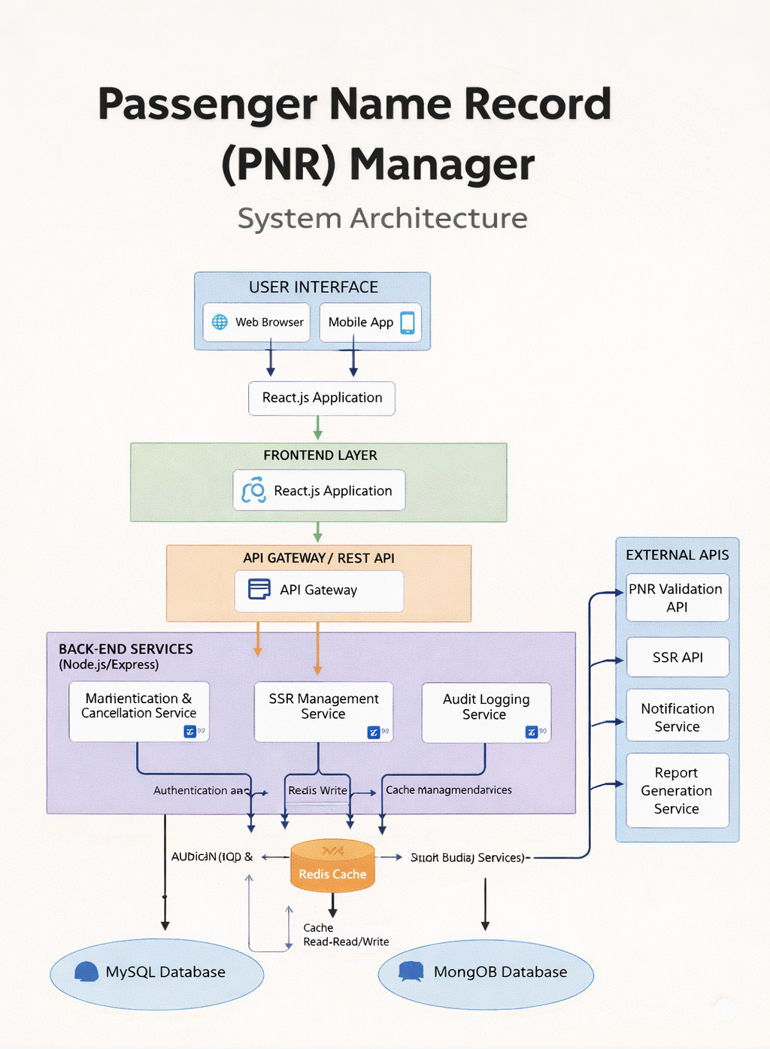

4.2 Description of Each Layer (Frontend, Backend, Database)
The architecture of the Passenger Name Record (PNR) Manager project is organized into three major layers — the frontend, backend, and database — each playing a distinct role in ensuring the system’s efficiency, scalability, and reliability. Together, these layers form a cohesive ecosystem that allows passengers, airline staff, and administrators to interact seamlessly while maintaining data integrity and operational transparency.
The frontend layer serves as the user interface and interaction point for all stakeholders. It is built using React.js, a modern JavaScript library known for its component-based architecture and dynamic rendering capabilities. React enables the creation of reusable components such as booking forms, modification panels, and dashboards, which streamline development and ensure consistency across the application. The frontend is designed with responsiveness in mind, adapting smoothly to different screen sizes and devices — from desktop browsers to mobile applications. HTML5 and CSS3 provide the structural and stylistic foundation, while Bootstrap or Tailwind CSS enhance the visual appeal and usability. JavaScript ES6+ powers interactivity, enabling real-time validation, dynamic updates, and asynchronous communication with the backend through RESTful APIs. Accessibility features such as keyboard navigation, screen-reader compatibility, and high-contrast themes ensure inclusivity for all users. The frontend’s primary goal is to deliver a clean, intuitive interface that minimizes user effort while maximizing clarity and control over bookings.
The backend layer acts as the logical core of the system, handling data processing, business rules, and communication between the frontend and the database. It is developed using Node.js and Express.js, which together provide a lightweight, event-driven environment capable of managing multiple concurrent requests efficiently. Node.js’s non-blocking architecture ensures that operations such as booking modifications, cancellations, and special service requests (SSRs) are processed quickly, even under heavy load. Express.js simplifies routing and middleware management, allowing developers to define clear endpoints for each functionality — for example, /createPNR, /modifyPNR, /cancelPNR, and /manageSSR. Authentication and authorization mechanisms are implemented using JSON Web Tokens (JWT), ensuring secure access control. Role-based permissions distinguish between passengers, staff, and administrators, preventing unauthorized actions. The backend also integrates caching through Redis to accelerate data retrieval and reduce database load. Error handling and logging mechanisms are embedded to maintain reliability and traceability. This layer ensures that every transaction — from booking creation to audit logging — follows strict validation and consistency rules, maintaining the integrity of passenger data.
The database layer forms the foundation of persistent data storage. It is designed using a hybrid approach that combines relational and non-relational databases to balance structure and flexibility. MySQL serves as the primary relational database, storing structured data such as passenger details, flight schedules, seat allocations, and booking histories. Tables are normalized to eliminate redundancy and maintain consistency, with foreign keys linking related entities like passengers and bookings. PostgreSQL can also be used for advanced query handling and transaction management. For unstructured or semi-structured data, such as logs, notifications, and audit trails, MongoDB is integrated as a NoSQL database. MongoDB’s document-based storage model allows rapid insertion and retrieval of dynamic data, making it ideal for real-time operations. Backup and recovery mechanisms are implemented to safeguard data against loss, while replication and clustering enhance availability and scalability. Together, these databases ensure that the system can handle large volumes of data efficiently while maintaining accuracy and security.
In summary, the three layers — frontend, backend, and database — work in harmony to deliver a robust, user-centric system. The frontend provides accessibility and interactivity, the backend enforces logic and security, and the database ensures reliable storage and retrieval. This layered architecture not only simplifies development and maintenance but also ensures scalability, making the PNR Manager adaptable to future enhancements and integrations.

4.3 Deployment Architecture (Cloud, Local, CI/CD Pipelines)
The deployment architecture of the Passenger Name Record (PNR) Manager project is designed to ensure reliability, scalability, and continuous delivery. It combines cloud-based infrastructure, local development environments, and automated CI/CD pipelines to create a seamless workflow from development to production. This architecture supports rapid updates, efficient resource utilization, and high availability — essential for an application that manages sensitive passenger data and real-time booking operations.
At the foundation of deployment lies the cloud infrastructure, which provides flexibility and scalability. Platforms such as Amazon Web Services (AWS), Microsoft Azure, or Google Cloud are ideal for hosting the application. The backend services, built on Node.js and Express, are deployed on cloud servers using containerization tools like Docker. Containers encapsulate the application and its dependencies, ensuring consistent performance across environments. Kubernetes or AWS Elastic Container Service (ECS) can be used for orchestration, automatically managing container scaling and load balancing. The frontend, developed in React.js, is hosted on cloud storage services such as AWS S3 or Azure Blob Storage, with a content delivery network (CDN) ensuring fast and reliable access worldwide. The databases — MySQL and MongoDB — are hosted on managed cloud services like Amazon RDS and MongoDB Atlas, providing automated backups, replication, and monitoring. This cloud-based setup ensures that the system can handle fluctuating traffic volumes while maintaining high uptime and performance.
The local development environment plays a crucial role in the early stages of deployment. Developers use tools such as Visual Studio Code, Git, and Docker Desktop to build and test the application locally. The environment mirrors the cloud configuration, ensuring that code behaves consistently across stages. Local testing includes unit tests, integration tests, and end-to-end tests using frameworks like Jest, Mocha, and Postman. Once validated, the code is pushed to a version control repository such as GitHub or GitLab, where it becomes part of the continuous integration pipeline.
The CI/CD pipeline automates the process of building, testing, and deploying the application. Continuous Integration (CI) ensures that every code change is automatically tested and validated. Tools such as Jenkins, GitHub Actions, or Travis CI monitor the repository for updates, trigger builds, and run test suites. This automation reduces human error and accelerates development. Continuous Deployment (CD) extends this process by automatically deploying successful builds to staging or production environments. Deployment scripts handle tasks such as container creation, environment configuration, and database migrations. Rollback mechanisms are implemented to revert to previous versions in case of deployment failures, ensuring stability. Monitoring tools like Prometheus and Grafana track system performance, while logging services such as ELK Stack (Elasticsearch, Logstash, Kibana) provide insights into application behavior.
Security and compliance are integral to the deployment architecture. SSL/TLS encryption secures data transmission, while firewalls and access control lists protect cloud resources. Regular vulnerability scans and automated patching maintain system integrity. Backup strategies ensure data recovery in case of failures, and disaster recovery plans define procedures for restoring services quickly.
In conclusion, the deployment architecture of the PNR Manager project combines the strengths of cloud computing, local development, and CI/CD automation. It ensures that the system remains scalable, secure, and continuously updated. By leveraging modern tools and practices, the architecture supports efficient collaboration, rapid innovation, and reliable service delivery — essential qualities for a system that manages critical airline booking operations.

CHAPTER -5 DESIGN
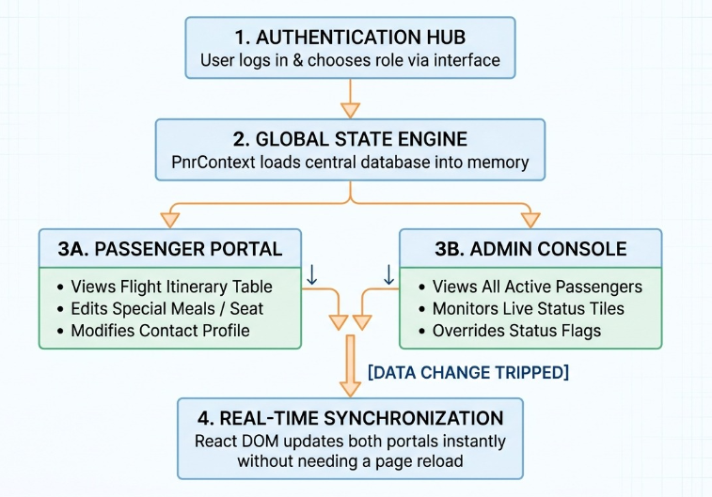

CHAPTER -6 IMPLEMENTATION

Section 6.1 – Module-Wise Implementation
The Passenger Name Record (PNR) Manager project is designed with a modular architecture, where each module is responsible for a distinct set of tasks. This modular approach is not only a technical choice but also a strategic one, ensuring that the system remains scalable, maintainable, and adaptable to future requirements. In large systems such as airline booking platforms, modularity is essential because it allows developers to isolate functionality, test components independently, and extend features without disrupting the entire ecosystem. In this chapter, we will explore each module in detail, examining its purpose, design, workflows, and interactions with other components.
The dashboard module serves as the central hub of the application. It provides administrators and staff with a summarized view of system activity, including total bookings, active passengers, pending special service requests, and recent modifications. Built using React components, the dashboard dynamically fetches data from the backend through RESTful APIs. It presents information in charts, tables, and graphs, allowing administrators to monitor performance and trends. For example, during peak travel seasons, the dashboard can highlight sudden increases in bookings or cancellations, enabling staff to respond proactively. The dashboard also includes quick navigation links to other modules, making it a central hub for system management. Its design emphasizes clarity and accessibility, ensuring that users can quickly grasp the state of the system without navigating through multiple pages.
The search PNR module is critical for retrieving booking details. It allows users to search using either the unique PNR code or passenger information. The frontend validates inputs in real time, ensuring that users enter correct formats before queries are sent to the backend. The backend then queries the MySQL database for matching records. When a valid PNR is found, the system displays complete details such as flight schedules, passenger data, and special service requests. Invalid or expired PNRs trigger error messages, ensuring clarity. This module is indispensable for passengers checking their booking status and for staff verifying records quickly. For instance, a passenger at the airport may need to confirm their booking details; the search module provides instant access, reducing delays and confusion.
The bookings module manages the creation, modification, and cancellation of passenger records. It includes forms for entering passenger details, flight schedules, and seat preferences. The backend validates each booking request to prevent duplication and ensure compliance with flight capacity limits. Batch booking functionality supports group travel, allowing multiple passengers to be processed simultaneously. Every booking action is recorded in the audit trail, ensuring transparency and accountability. This module is the backbone of the system, as it directly handles the core function of managing passenger records. Consider a scenario where a family of five books tickets together; the batch booking feature ensures that all records are created in one transaction, reducing errors and improving efficiency.
The special service request (SSR) module addresses additional passenger needs such as meal preferences, wheelchair assistance, or medical support. It communicates with the backend SSR service, which stores and updates these requests in the MongoDB database. The frontend provides intuitive interfaces such as dropdown menus and checkboxes, while the backend ensures that requests align with airline policies. Notifications are triggered automatically when SSRs are approved or modified, keeping passengers informed. This module enhances inclusivity and customer satisfaction. For example, a passenger requiring wheelchair assistance can submit a request during booking, and the system ensures that staff are notified well in advance, improving service quality.
The audit trail module logs every user action, including booking creation, modification, cancellation, and data export. The backend writes these logs to MongoDB, allowing quick retrieval and flexible storage. Administrators can filter logs by date, user, or action type, supporting compliance with data protection regulations. This module ensures that all operations are traceable and verifiable, which is critical in industries where accountability is paramount. For instance, if a booking is modified incorrectly, administrators can trace the action back to the responsible user, ensuring accountability and enabling corrective measures.
The notifications module provides real-time communication between the system and users. It uses Firebase or WebSocket integration to push alerts about booking updates, cancellations, or SSR approvals. Notifications appear as pop-ups or dashboard messages, improving responsiveness and engagement. This module ensures that passengers and staff remain informed about critical changes. Imagine a passenger whose flight has been rescheduled; the notification module ensures that they receive an instant alert, reducing confusion and improving trust in the system.
The history module displays a chronological record of past bookings and modifications. It retrieves archived data from the database and presents it in a paginated format. This helps users track changes over time and supports audit verification. The module is particularly useful for administrators who need to review historical data for compliance or analysis. For example, an airline may need to analyze booking patterns over the past year; the history module provides structured access to this data, supporting decision-making and strategic planning.
The export data module allows administrators to generate reports in formats such as CSV or PDF. It interacts with the backend reporting service, which compiles data from multiple tables and structures it for export. This module is essential for analytics, compliance reporting, and decision-making. For instance, an administrator may need to generate a monthly report on cancellations and SSR requests; the export module provides this data in a structured format, enabling analysis and compliance with regulatory requirements.
Finally, the settings module enables customization of user preferences, access roles, and system configurations. It interacts with the authentication service to manage credentials and permissions. Each module communicates through APIs, ensuring smooth data flow and consistent functionality across the system. For example, administrators can configure role-based access, ensuring that passengers, staff, and administrators have appropriate permissions. This module ensures flexibility and adaptability, allowing the system to evolve with changing requirements.
In conclusion, the module-wise implementation of the Passenger Name Record Manager project demonstrates the importance of modular architecture in complex systems. Each module serves a distinct purpose, from managing bookings to handling special service requests, logging actions, sending notifications, and generating reports. Together, these modules create a cohesive ecosystem that supports the diverse needs of passengers, staff, and administrators. By emphasizing modularity, the system ensures scalability, maintainability, and adaptability, making it a robust solution for airline booking management.

Section 6.2 – Front-End Logic (UI Rendering and State Management)
The front-end of the Passenger Name Record Manager project is the layer that passengers, airline staff, and administrators interact with directly. It is the face of the system, responsible for rendering the user interface, managing state, and ensuring that interactions are smooth, responsive, and intuitive. In a system as complex as airline booking management, the front-end must balance clarity with functionality, providing users with the tools they need while maintaining accessibility and performance. This chapter explores the front-end logic in depth, focusing on user interface rendering, state management, navigation, validation, accessibility, and performance optimization.
At the heart of the front-end lies React.js, a modern JavaScript library chosen for its efficiency, modularity, and dynamic rendering capabilities. React’s component-based architecture allows developers to build reusable UI elements that encapsulate both logic and presentation. Each module of the PNR Manager, such as Dashboard, Search PNR, Bookings, SSR, Audit Trail, Notifications, History, Export, and Settings, is represented by distinct React components. These components communicate through props and state, maintaining a clear separation of concerns. For example, the booking form component handles input fields and validation, while the dashboard component focuses on data visualization. This modularity ensures consistency across the application and simplifies maintenance.
UI rendering in React is powered by the virtual DOM, which efficiently updates only the parts of the interface that change. This is particularly important in a system where data is frequently updated, such as when passengers modify bookings or administrators approve SSRs. Instead of reloading entire pages, React updates specific components, ensuring that the interface remains responsive. Conditional rendering further enhances clarity by displaying only relevant data based on user roles and actions. For instance, passengers see their booking details and modification options, while administrators access audit logs and system settings. This role-based rendering ensures that users are not overwhelmed with unnecessary information.
Navigation within the application is handled by React Router, which enables smooth transitions between pages without full reloads. This single-page architecture enhances performance and user experience, as users can move between modules seamlessly. For example, a passenger can navigate from the dashboard to the search module and then to the booking modification form without experiencing delays. React Router also supports nested routes, allowing complex navigation structures to be implemented cleanly. This is essential in a system with multiple interconnected modules.
State management is a critical aspect of front-end logic, ensuring that data remains consistent across components. The PNR Manager uses React’s Context API for simple state sharing and Redux for more complex scenarios. Global states such as user authentication, booking data, and notifications are stored centrally, allowing components to access and update them efficiently. Actions and reducers manage state transitions, ensuring predictable behavior. For example, when a booking is modified, the state updates instantly, and the dashboard reflects the change without manual refresh. This real-time synchronization enhances user trust and system reliability.
Form validation and error handling are implemented to ensure data accuracy. Input fields are validated using both client-side and server-side checks to prevent incorrect submissions. For instance, the booking form validates passenger names, flight numbers, and seat preferences before sending data to the backend. Error messages provide clear feedback, guiding users to correct mistakes. Loading indicators and success or error messages enhance transparency during API calls. Asynchronous functions and hooks like useEffect and useState ensure smooth data fetching and rendering, maintaining responsiveness even under heavy load.
Accessibility is a key focus of the front-end design. The UI supports keyboard navigation, screen readers, and high-contrast themes, ensuring inclusivity for all users. Semantic HTML elements improve compatibility with assistive technologies, while ARIA attributes enhance accessibility further. Responsive design principles ensure that the interface adapts to different screen sizes, maintaining usability on desktops, tablets, and mobile devices. For example, passengers accessing the system on smartphones experience the same clarity and functionality as those using desktops. This inclusivity is essential in a global system serving diverse users.
Performance optimization is another critical aspect of front-end logic. Techniques such as lazy loading, code splitting, and memorization are employed to reduce load times and enhance responsiveness. Lazy loading ensures that components are loaded only when needed, reducing initial load times. Code splitting divides the application into smaller bundles, allowing faster rendering. Memorization prevents unnecessary re-rendering of components, improving efficiency. Together, these techniques ensure that the system remains fast and reliable, even under heavy traffic.
The front-end also emphasizes user experience through thoughtful design. Icons, color schemes, and typography are used strategically to improve readability and navigation. For example, green indicators highlight successful actions, while red alerts signal errors. Consistent design patterns across modules enhance familiarity, reducing the learning curve for new users. Micro-interactions, such as hover effects and animations, provide feedback and improve engagement. These design choices contribute to a user-friendly interface that balances functionality with aesthetics.
In conclusion, the front-end logic of the Passenger Name Record Manager project demonstrates the importance of clarity, responsiveness, and inclusivity in complex systems. By leveraging React.js, React Router, Context API, Redux, and modern design principles, the front-end delivers a seamless user experience. It ensures that passengers, staff, and administrators can interact with the system efficiently, with real-time updates, accurate validation, and accessible design. This chapter highlights the role of front-end logic in shaping user perceptions and trust, making it a critical component of the overall architecture.

6.3 API Integration
In the Passenger Name Record Manager project, API integration is the backbone of communication between the front-end and back-end layers. Without well-designed APIs, the system would be fragmented, with modules unable to exchange data reliably. APIs provide the structured pathways through which requests are sent, processed, and responded to, ensuring that passengers, staff, and administrators experience seamless interactions. This chapter explores API integration in depth, covering design principles, endpoint structures, workflows, error handling, security, scalability, and integration with external services.
At its core, the project uses RESTful APIs built with Express.js. REST (Representational State Transfer) is chosen because of its simplicity, scalability, and widespread adoption. Each API endpoint corresponds to a specific functionality, such as creating a booking, modifying a PNR, handling cancellations, or managing special service requests. These endpoints are designed to be stateless, meaning that each request contains all the information needed to process it. This design ensures scalability, as servers do not need to maintain session information between requests.
The search PNR API is one of the most frequently used endpoints. It allows users to retrieve booking details using parameters such as PNR code or passenger name. The front-end sends requests using Axios, a JavaScript library for handling HTTP requests. The backend queries the MySQL database and returns structured JSON responses. For example, a request might include a PNR code, and the response would contain passenger details, flight schedules, and SSRs. Error handling ensures that invalid or expired PNRs trigger appropriate messages, guiding users to correct inputs. This API is critical for passengers verifying their bookings and for staff managing records.
The booking API manages creation, modification, and cancellation of records. It validates input data, checks flight availability, and updates the database accordingly. For instance, when a passenger books a flight, the API ensures that seats are available, passenger details are valid, and payment is processed. Once validated, the booking is stored in the database, and notifications are triggered. Modification requests follow similar workflows, with the API validating changes before updating records. Cancellation requests are processed with checks to ensure compliance with airline policies. Batch processing endpoints handle group bookings efficiently, allowing multiple passengers to be booked or modified in one transaction.
The SSR API manages special service requests. It interacts with the MongoDB database to store and update SSR details. The API ensures that requests comply with airline policies and triggers alerts when changes occur. For example, a passenger requesting a vegetarian meal submits the request through the front-end, which sends it to the SSR API. The backend validates the request, stores it in MongoDB, and triggers a notification to staff. This workflow ensures that passengers receive personalized services while maintaining compliance.
The audit trail API records user actions and retrieves logs for administrative review. It supports filtering and pagination, allowing efficient access to large datasets. For instance, administrators can query logs for a specific date range or user, retrieving structured data that highlights actions taken. This API ensures accountability and transparency, which are critical in industries where compliance is mandatory.
The notification API integrates with Firebase or WebSocket services to push real-time updates. It ensures that users receive timely alerts about booking changes or approvals. For example, when a booking is modified, the API triggers a notification that appears as a pop-up on the dashboard. This real-time communication enhances user trust and engagement.
API design follows best practices to ensure reliability and scalability. Endpoints are named clearly, using nouns and verbs that reflect functionality. For example, /createPNR, /modifyPNR, /cancelPNR, and /manageSSR are intuitive and self-explanatory. Responses are standardized, using JSON structures that include status codes, messages, and data. This consistency ensures that the front-end can handle responses predictably. Error codes follow HTTP standards, with codes such as 400 for bad requests, 401 for unauthorized access, and 404 for not found. Detailed error messages provide clarity, guiding users to correct mistakes.
Security is a critical aspect of API integration. All APIs are secured using JWT authentication and HTTPS encryption. JWT ensures that only authorized users can access endpoints, while HTTPS protects data in transit. Input sanitization prevents SQL injection and cross-site scripting attacks, while rate limiting prevents abuse by restricting the number of requests per user. Middleware functions in Express.js handle authentication and authorization, ensuring that requests are validated before processing. For example, passengers can access booking endpoints, but only administrators can access audit trail endpoints. This role-based access control ensures compliance and security.
Scalability is achieved through techniques such as caching, load balancing, and microservices architecture. Caching stores frequently accessed data in memory, reducing database load and improving response times. Load balancing distributes requests across multiple servers, ensuring that the system remains responsive under heavy traffic. Microservices architecture divides the system into smaller services, each responsible for specific functionality. For example, the booking service handles bookings, while the SSR service manages special requests. This division enhances scalability and maintainability, as services can be updated independently.
Integration with external services extends the functionality of the system. Payment gateways such as Stripe are integrated through APIs, allowing secure transactions. Firebase provides real-time notifications, while cloud storage services handle backups and recovery. Analytics platforms integrate through APIs to monitor trends and performance. For example, administrators can use analytics APIs to track booking patterns, cancellations, and SSR requests, supporting decision-making and strategic planning.
Error handling is implemented to ensure reliability. APIs return detailed error messages, guiding users to correct inputs. For example, if a passenger enters an invalid PNR code, the API returns a message indicating the error. Logging mechanisms capture errors for analysis, allowing developers to identify and fix issues. Retry mechanisms ensure that temporary failures do not disrupt workflows. For instance, if a notification fails to send, the system retries until successful.
In conclusion, API integration is the backbone of the Passenger Name Record Manager project. It ensures seamless communication between the front-end and back-end, enabling functionalities such as booking creation, modification, cancellation, SSR management, audit logging, and notifications. By following best practices in design, security, scalability, and error handling, the APIs provide reliability and efficiency. Integration with external services extends functionality, making the system adaptable and future-proof. This chapter highlights the critical role of APIs in shaping the system’s architecture, ensuring that passengers, staff, and administrators experience seamless interactions.

6.4 Authentication and Authorisation
Authentication and authorization are the twin pillars of security in any modern application, and in the Passenger Name Record (PNR) Manager project they play a particularly critical role. Airline booking systems handle sensitive personal information, financial transactions, and operational data that must be protected against unauthorized access and misuse. Without robust authentication and authorization mechanisms, the system would be vulnerable to breaches, fraud, and regulatory non-compliance. This chapter explores authentication and authorization in depth, covering design principles, workflows, technologies, role-based access control, session management, security measures, compliance, and real-world scenarios.
Authentication is the process of verifying the identity of a user. In the PNR Manager, authentication begins when a passenger, staff member, or administrator attempts to log in. The system requires credentials such as a username and password, which are verified against records stored in the database. To enhance security, passwords are never stored in plain text. Instead, they are encrypted using hashing algorithms such as bcrypt. Hashing ensures that even if the database is compromised, attackers cannot easily retrieve original passwords. Salting further strengthens security by adding random data to each password before hashing, preventing common attacks such as rainbow table lookups.
Once credentials are verified, the system generates a JSON Web Token (JWT). This token serves as proof of authentication and is sent to the client, which stores it temporarily. The token is included in subsequent API requests, allowing the backend to verify the user’s identity without requiring repeated logins. JWTs are stateless, meaning that servers do not need to maintain session information. This design enhances scalability, as servers can handle large volumes of requests without storing session data. Tokens include payloads that contain user information, such as roles and permissions, ensuring that authorization checks can be performed efficiently.
Authorization defines what actions a user can perform once authenticated. In the PNR Manager, role-based access control (RBAC) is implemented to distinguish between passengers, airline staff, and administrators. Passengers can view and modify their bookings, submit SSRs, and receive notifications. Staff can manage SSRs, handle cancellations, and assist passengers. Administrators have full access to audit logs, system settings, and reporting tools. Middleware functions in the backend check user roles before processing requests, ensuring that only authorized actions are performed. For example, a passenger cannot access audit logs, and staff cannot modify system settings. This role-based division ensures compliance and security.
Session management is another critical aspect of authentication and authorization. Tokens are designed to expire after a certain period, reducing the risk of misuse. Expired tokens require users to log in again, ensuring that access is not maintained indefinitely. Refresh tokens can be used to extend sessions securely without requiring frequent logins. Logout functionality invalidates tokens immediately, ensuring that access is revoked when users leave the system. These mechanisms balance security with usability, ensuring that users remain authenticated without compromising safety.
Additional security measures are implemented to protect against common threats. HTTPS encryption secures data transmission, preventing attackers from intercepting sensitive information. Firewalls and access control lists protect cloud resources, ensuring that only authorized traffic is allowed. Input validation prevents SQL injection and cross-site scripting attacks, while rate limiting prevents abuse by restricting the number of requests per user. Multi-factor authentication (MFA) can be implemented to enhance security further, requiring users to provide additional verification such as a code sent to their mobile device. These measures create a layered defense that protects the system against diverse threats.
Compliance with data protection regulations is another critical aspect of authentication and authorization. Regulations such as GDPR and HIPAA require systems to protect personal data and ensure accountability. The PNR Manager implements audit trails that log login attempts, successful authentications, and authorization checks. These logs provide transparency and accountability, ensuring that actions can be traced back to specific users. Administrators can review logs to identify suspicious activity, such as repeated failed login attempts, and take corrective measures. Compliance ensures that the system meets legal requirements and builds trust among users.
Real-world scenarios highlight the importance of authentication and authorization. Consider a passenger attempting to modify their booking. The system verifies their identity through authentication, generates a token, and checks their role through authorization. The passenger is allowed to modify their booking but not access audit logs. Another scenario involves staff handling SSRs. The system verifies their identity, checks their role, and grants access to SSR management tools. Administrators, on the other hand, can access all modules, including audit trails and reporting tools. These scenarios demonstrate how authentication and authorization ensure that users can perform appropriate actions while preventing unauthorized access.
Authentication and authorization also play a role in scalability and performance. Stateless tokens ensure that servers can handle large volumes of requests without storing session data. Role-based access control ensures that requests are processed efficiently, as permissions are checked quickly. These mechanisms ensure that the system remains responsive and reliable, even under heavy traffic. For example, during peak travel seasons, thousands of passengers may log in simultaneously. Stateless tokens and efficient authorization checks ensure that the system can handle this load without compromising performance.
In conclusion, authentication and authorization form the security backbone of the Passenger Name Record Manager project. Authentication verifies user identities through secure login systems, encrypted passwords, and JWT tokens. Authorization defines user roles and permissions, ensuring that actions are performed appropriately. Session management balances security with usability, while additional measures such as HTTPS encryption, firewalls, input validation, and MFA create layered defenses. Compliance with data protection regulations ensures accountability and trust. Real-world scenarios highlight the importance of these mechanisms in maintaining security and reliability. Together, authentication and authorization ensure that the PNR Manager remains a secure, scalable, and trustworthy system for managing airline bookings.

CHAPTER 7- FEATURES

7.1 List of Main Features
The Passenger Name Record Manager project is a comprehensive system designed to handle the complexities of airline booking management. Its strength lies in the wide range of features it offers, each carefully crafted to address specific needs of passengers, staff, and administrators. In this chapter, we will explore the main features in detail, examining their purpose, scope, and contribution to the overall system. By the end, it will be clear how these features collectively form a robust, user-centric solution.
The dashboard feature serves as the central hub of the application. It provides a summarized view of system activity, displaying metrics such as total bookings, active passengers, pending special service requests, and recent modifications. The dashboard is designed to be visually intuitive, using charts, tables, and graphs to present data clearly. For administrators, it acts as a control center, enabling them to monitor performance and trends at a glance. For staff, it provides quick access to operational data, improving efficiency. The dashboard is not just a feature; it is the heartbeat of the system, ensuring that users remain informed and engaged.
The search PNR feature allows users to retrieve booking details using either the unique PNR code or passenger information. This feature is critical for passengers who want to verify their bookings and for staff who need to manage records quickly. The search functionality is designed to be fast and accurate, with real-time validation ensuring that inputs are correct. By providing instant access to booking details, the search feature reduces delays and confusion, enhancing user trust and satisfaction.
The bookings feature manages the creation, modification, and cancellation of passenger records. It includes forms for entering passenger details, flight schedules, and seat preferences. The backend validates each booking request to prevent duplication and ensure compliance with flight capacity limits. Batch booking functionality supports group travel, allowing multiple passengers to be processed simultaneously. This feature is the backbone of the system, as it directly handles the core function of managing passenger records. Without it, the system would lack its primary purpose.
The special service request feature addresses additional passenger needs such as meal preferences, wheelchair assistance, or medical support. It ensures inclusivity by allowing passengers to customize their travel experience. The SSR feature communicates with the backend service, which stores and updates requests in the database. Notifications are triggered automatically when SSRs are approved or modified, keeping passengers informed. This feature enhances customer satisfaction by providing personalized services that meet diverse needs.
The audit trail feature is critical for accountability and compliance. It logs every user action, including booking creation, modification, cancellation, and data export. Administrators can filter logs by date, user, or action type, supporting compliance with data protection regulations. This feature ensures that all operations are traceable and verifiable, which is essential in industries where accountability is paramount. By maintaining immutable records of system activity, the audit trail builds trust and transparency.
The notifications feature provides real-time communication between the system and users. It uses technologies such as Firebase or WebSocket integration to push alerts about booking updates, cancellations, or SSR approvals. Notifications appear as pop-ups or dashboard messages, improving responsiveness and engagement. This feature ensures that passengers and staff remain informed about critical changes, reducing confusion and enhancing trust.
The history feature displays a chronological record of past bookings and modifications. It retrieves archived data from the database and presents it in a structured format. This feature helps users track changes over time and supports audit verification. For administrators, it provides valuable insights into booking patterns and system usage. For passengers, it offers transparency by showing how their bookings have evolved. The history feature is essential for analysis and compliance.
The export data feature allows administrators to generate reports in formats such as CSV or PDF. It interacts with the backend reporting service, which compiles data from multiple tables and structures it for export. This feature is essential for analytics, compliance reporting, and decision-making. By providing structured access to data, the export feature supports strategic planning and regulatory compliance.
The settings feature enables customization of user preferences, access roles, and system configurations. It interacts with the authentication service to manage credentials and permissions. This feature ensures flexibility and adaptability, allowing the system to evolve with changing requirements. For example, administrators can configure role-based access, ensuring that passengers, staff, and administrators have appropriate permissions. The settings feature is critical for maintaining security and usability.
Together, these features form a cohesive ecosystem that supports the diverse needs of passengers, staff, and administrators. Each feature serves a distinct purpose, from managing bookings to handling special service requests, logging actions, sending notifications, and generating reports. By emphasizing modularity and user-centric design, the system ensures scalability, maintainability, and adaptability. The features are not isolated; they interact seamlessly, creating a robust solution that addresses the complexities of airline booking management.
In conclusion, the list of main features in the Passenger Name Record Manager project highlights the system’s comprehensive scope and user-centric design. The dashboard, search PNR, bookings, SSR, audit trail, notifications, history, export data, and settings features collectively form a robust solution that meets the diverse needs of users. Each feature contributes to the system’s reliability, transparency, and efficiency, making the PNR Manager a powerful tool for airline booking management.

7.2 How Each Feature Works
The Passenger Name Record Manager project is not just a collection of features; it is a system where each feature is carefully designed to serve both the user’s needs and the technical requirements of the application. To understand the depth of the system, it is important to look at how each feature works from two perspectives: the user’s experience and the technical implementation behind the scenes. This dual view highlights the balance between usability and engineering, showing how the system achieves reliability, efficiency, and inclusivity.
The dashboard feature is the first point of interaction for most users. From the user’s perspective, the dashboard provides a clear overview of system activity. Passengers see their upcoming bookings, notifications, and recent changes. Staff members view operational data such as pending SSRs and cancellations. Administrators access metrics such as total bookings, active passengers, and audit logs. The dashboard is designed to be visually intuitive, using charts, tables, and graphs to present data clearly. Technically, the dashboard is built with React components that fetch data from the backend through RESTful APIs. The backend aggregates data from multiple sources, including MySQL for structured booking data and MongoDB for logs. The data is processed and sent to the front-end in JSON format, which is then rendered dynamically. The use of the virtual DOM ensures that updates are efficient, with only changed components re-rendered. This combination of user-centric design and technical efficiency makes the dashboard a powerful tool for monitoring and management.
The search PNR feature allows users to retrieve booking details quickly. From the user’s perspective, this feature is straightforward: they enter a PNR code or passenger name, and the system displays the relevant booking details. The interface validates inputs in real time, ensuring that users enter correct formats. If the PNR is valid, details such as flight schedules, passenger information, and SSRs are displayed. If the PNR is invalid or expired, the system provides clear error messages. Technically, the search feature uses Axios to send requests to the backend, which queries the MySQL database. The backend validates inputs, processes queries, and returns structured JSON responses. Error handling mechanisms ensure reliability, while caching improves performance by storing frequently accessed data. This combination of user-friendly design and technical robustness makes the search feature indispensable.
The bookings feature manages the creation, modification, and cancellation of passenger records. From the user’s perspective, this feature provides forms for entering passenger details, flight schedules, and seat preferences. The interface validates inputs, ensuring accuracy before submission. Users receive feedback through success or error messages, guiding them through the process. Technically, the bookings feature interacts with the backend through RESTful APIs. The backend validates data, checks flight availability, and updates the database. Batch booking functionality allows multiple passengers to be processed simultaneously, with the backend handling group transactions efficiently. Audit trails record every booking action, ensuring transparency. This combination of usability and technical rigor makes the bookings feature the backbone of the system.
The special service request feature addresses additional passenger needs. From the user’s perspective, this feature provides options such as meal preferences, wheelchair assistance, or medical support. Passengers select options through dropdown menus and checkboxes, customizing their travel experience. Staff members receive notifications when SSRs are submitted, enabling them to respond promptly. Technically, the SSR feature interacts with the backend service, which stores requests in MongoDB. The backend validates requests, ensuring compliance with airline policies. Notifications are triggered automatically, keeping passengers informed. This combination of personalization and technical reliability makes the SSR feature essential for inclusivity.
The audit trail feature ensures accountability. From the user’s perspective, administrators can view logs of actions such as booking creation, modification, and cancellation. Logs can be filtered by date, user, or action type, providing transparency. Technically, the audit trail feature records actions in MongoDB, storing them in structured formats. The backend provides APIs for retrieving logs, supporting filtering and pagination. This combination of transparency and technical efficiency ensures compliance with regulations and builds trust.
The notifications feature provides real-time communication. From the user’s perspective, notifications appear as pop-ups or dashboard messages, informing them of booking updates, cancellations, or SSR approvals. Technically, the notifications feature uses Firebase or WebSocket integration to push alerts. The backend triggers notifications when actions occur, ensuring real-time communication. This combination of responsiveness and technical reliability enhances user engagement.
The history feature provides transparency. From the user’s perspective, it displays a chronological record of past bookings and modifications. Users can view how their bookings have evolved over time. Administrators can analyse booking patterns and system usage.

CHAPTER -8 TESTING

8.1 Postman Testing (Frontend/Backend)
Postman testing plays a central role in validating the functionality of both the frontend and backend of the Passenger Name Record Manager project. Postman is a widely used tool for API testing, and in this system it ensures that the communication between the user interface and the server is reliable, secure, and efficient. This chapter explores Postman testing in depth, covering its purpose, workflows, test design, validation strategies, error handling, and its contribution to overall system quality.
From a frontend perspective, Postman testing is used to simulate the requests that the user interface sends to the backend. When a passenger searches for a PNR, modifies a booking, or submits a special service request, the frontend sends HTTP requests to the backend APIs. Postman allows developers to replicate these requests manually, ensuring that the APIs respond correctly. For example, a GET request to the search PNR endpoint should return structured JSON containing passenger details, flight schedules, and SSRs. By testing this endpoint in Postman, developers can confirm that the response matches expectations before integrating it into the frontend. This reduces the risk of errors during user interactions.
From a backend perspective, Postman testing validates the logic and workflows implemented in the server. The backend is responsible for processing requests, validating inputs, interacting with databases, and returning responses. Postman allows developers to send requests with different parameters, testing how the backend handles valid and invalid inputs. For instance, a POST request to the booking endpoint should create a new record if inputs are valid, but return an error if flight capacity is exceeded. By testing these scenarios in Postman, developers ensure that the backend enforces business rules consistently. This strengthens reliability and prevents misuse.
Postman testing also supports automated workflows through collections. Collections are groups of requests organized by functionality, such as bookings, SSRs, audit trails, and notifications. Developers can run entire collections to validate multiple endpoints simultaneously. For example, a collection for bookings might include requests for creating, modifying, and canceling records. Running the collection ensures that all related endpoints function correctly together. This holistic approach reduces the risk of isolated errors and ensures consistency across modules.
Validation strategies in Postman testing include checking response codes, response times, and response bodies. Response codes indicate whether requests are successful or failed. For example, a 200 code indicates success, while a 400 code indicates a bad request. Response times measure performance, ensuring that APIs respond within acceptable limits. Response bodies contain data, which must match expected structures. Postman allows developers to write tests that validate these aspects automatically. For instance, a test might check that the response body contains a passenger name field, ensuring that data is returned correctly. These validation strategies ensure accuracy and reliability.
Error handling is another critical aspect of Postman testing. APIs must handle invalid inputs gracefully, returning clear error messages. Postman allows developers to test scenarios such as missing parameters, incorrect formats, and unauthorized access. For example, sending a request without a valid token should return a 401 unauthorized error. Testing these scenarios ensures that the system provides clear feedback to users and prevents misuse. Error handling also strengthens security by preventing attackers from exploiting vulnerabilities.
Postman testing contributes to overall system quality by bridging the gap between frontend and backend development. It ensures that APIs function correctly before integration, reducing the risk of errors during user interactions. It validates business rules, strengthens security, and improves performance. By supporting automated workflows, Postman testing enhances efficiency and consistency. It also provides transparency, allowing developers to document and share test results with teams. This collaborative approach strengthens accountability and trust.
In conclusion, Postman testing is a critical component of the Passenger Name Record Manager project. It validates the functionality of both the frontend and backend, ensuring that APIs respond correctly, enforce business rules, and handle errors gracefully. By supporting automated workflows, validation strategies, and error handling, Postman testing strengthens reliability, security, and performance. It bridges the gap between development and testing, making it an indispensable tool for ensuring system quality.

8.2 Integration Testing
Integration testing is one of the most critical phases in the development of the Passenger Name Record Manager project. While unit testing focuses on individual components or functions, integration testing examines how these components work together as a whole. In a system as complex as airline booking management, where multiple modules interact through APIs, databases, and user interfaces, integration testing ensures that the system functions cohesively. This chapter explores integration testing in depth, covering its purpose, workflows, strategies, tools, challenges, and contributions to overall system quality.
The purpose of integration testing is to validate that modules interact correctly. Each module in the PNR Manager, such as dashboard, search PNR, bookings, SSR, audit trail, notifications, history, export data, and settings, is developed independently. While unit tests confirm that each module works in isolation, integration tests confirm that they work together. For example, when a passenger modifies a booking, the bookings module updates the database, the audit trail module logs the action, and the notifications module alerts the passenger. Integration testing ensures that these interactions occur seamlessly, without errors or inconsistencies.
Workflows in integration testing begin with identifying critical interactions between modules. Test cases are designed to simulate real-world scenarios, such as booking creation, modification, cancellation, and SSR submission. Each scenario involves multiple modules, requiring careful coordination. For instance, a booking creation workflow involves the bookings module, the database, the audit trail, and notifications. Integration tests simulate this workflow, validating that data flows correctly between modules. This holistic approach ensures that the system functions as intended in real-world use.
Strategies for integration testing include top-down, bottom-up, and hybrid approaches. The top-down approach begins with high-level modules, integrating lower-level modules gradually. This approach validates overall workflows early, ensuring that critical interactions are tested first. The bottom-up approach begins with lower-level modules, integrating higher-level modules gradually. This approach ensures that foundational components are validated before complex workflows. The hybrid approach combines both, providing flexibility and efficiency. In the PNR Manager, a hybrid approach is often used, as it allows developers to validate both foundational components and high-level workflows simultaneously.
Tools used in integration testing include Postman, Selenium, and automated testing frameworks. Postman is used to test API interactions, ensuring that requests and responses flow correctly between modules. Selenium is used to test user interface interactions, ensuring that frontend components communicate correctly with the backend. Automated testing frameworks such as Jest and Mocha are used to run integration tests systematically, providing consistency and efficiency. These tools provide transparency, allowing developers to document and share test results with teams.
Challenges in integration testing include complexity, data consistency, and error handling. The PNR Manager involves multiple modules, databases, and APIs, making integration testing complex. Ensuring data consistency across modules is critical, as errors can lead to incorrect bookings or SSRs. Error handling must be validated, ensuring that the system provides clear feedback to users and prevents misuse. For example, if a booking modification fails due to flight capacity limits, the system must return a clear error message, log the action, and prevent notifications from being sent. Integration testing ensures that these scenarios are handled correctly.
Integration testing contributes to overall system quality by validating workflows, strengthening reliability, and improving user trust. It ensures that modules interact correctly, preventing errors and inconsistencies. It validates business rules, ensuring compliance with airline policies. It strengthens security by validating authentication and authorization workflows. It improves performance by identifying bottlenecks in data flow. By providing transparency, integration testing builds trust among developers, administrators, and users.
Real-world scenarios highlight the importance of integration testing. Consider a passenger creating a booking. The bookings module validates inputs, updates the database, logs the action, and triggers notifications. Integration testing ensures that each step occurs correctly, without errors. Another scenario involves staff handling SSRs. The SSR module stores requests, the database updates records, and notifications alert staff. Integration testing ensures that these interactions occur seamlessly. These scenarios demonstrate how integration testing validates real-world workflows, ensuring reliability and efficiency.
In conclusion, integration testing is a critical phase in the development of the Passenger Name Record Manager project. It validates that modules interact correctly, ensuring that workflows function seamlessly. By using strategies such as top-down, bottom-up, and hybrid approaches, and tools such as Postman, Selenium, and automated frameworks, integration testing strengthens reliability, security, and performance. It addresses challenges such as complexity, data consistency, and error handling, ensuring that the system functions cohesively. Real-world scenarios highlight its importance in validating workflows and building trust. Together, integration testing ensures that the PNR Manager remains a robust, reliable, and user-centric system.

8.3 Tools Used for Testing
Testing tools are the backbone of quality assurance in any software project, and in the Passenger Name Record Manager they play a vital role in ensuring that the system is reliable, secure, and user-friendly. Because the project involves multiple modules, databases, APIs, and user interfaces, manual testing alone would be insufficient. Automated and semi-automated tools provide efficiency, consistency, and transparency, allowing developers to validate functionality across the entire system. This chapter explores the tools used for testing in depth, covering their purpose, workflows, strengths, limitations, and contributions to overall system quality.
One of the most important tools used in the project is Postman. Postman is widely recognized for its ability to test APIs, and in the PNR Manager it ensures that communication between the frontend and backend is reliable. Developers use Postman to send requests to endpoints such as booking creation, modification, cancellation, and SSR submission. Postman validates responses, checking status codes, response times, and response bodies. Collections allow developers to group related requests, running them together to validate workflows. For example, a collection for bookings might include requests for creating, modifying, and canceling records. Running the collection ensures that all related endpoints function correctly. Postman’s strengths include ease of use, automation capabilities, and transparency. Its limitations include a focus on API testing, meaning that it does not cover user interface interactions directly. Nevertheless, Postman is indispensable for validating backend functionality.
Another critical tool is Selenium. Selenium is used for testing user interfaces, ensuring that frontend components interact correctly with the backend. In the PNR Manager, Selenium scripts simulate user actions such as searching for a PNR, creating a booking, or submitting an SSR. These scripts validate that the interface responds correctly, displaying appropriate messages and updating components dynamically. Selenium supports multiple browsers, ensuring cross-platform compatibility. Its strengths include automation, flexibility, and support for complex workflows. Its limitations include complexity in script creation and maintenance, especially for dynamic interfaces. Despite these challenges, Selenium is essential for validating user interactions and ensuring usability.
Automated testing frameworks such as Jest and Mocha are also used in the project. These frameworks support unit and integration testing, providing consistency and efficiency. In the PNR Manager, Jest is used to test React components, ensuring that they render correctly and handle state transitions predictably. Mocha is used to test backend logic, validating workflows such as booking creation and SSR management. These frameworks support assertions, mocking, and coverage analysis, providing transparency and accountability. Their strengths include automation, flexibility, and support for continuous integration. Their limitations include complexity in setup and maintenance, especially for large projects. Nevertheless, they are critical for ensuring reliability and consistency.
Database testing tools are used to validate data consistency and integrity. In the PNR Manager, MySQL and MongoDB are used for structured and unstructured data. Tools such as DbUnit and MongoDB Compass validate queries, ensuring that data is stored and retrieved correctly. For example, DbUnit can populate databases with test data, run queries, and validate results. MongoDB Compass provides a graphical interface for exploring collections, validating that SSRs and audit logs are stored correctly. These tools ensure that data remains consistent across modules, preventing errors and inconsistencies. Their strengths include transparency and efficiency, while their limitations include a focus on database testing, meaning that they do not cover user interface interactions directly.
Performance testing tools such as JMeter are used to validate scalability and responsiveness. In the PNR Manager, JMeter simulates heavy traffic, sending multiple requests to endpoints simultaneously. This validates that the system remains responsive under load, identifying bottlenecks and performance issues. For example, JMeter can simulate thousands of passengers searching for PNRs during peak travel seasons. The results highlight response times, throughput, and error rates, providing insights into scalability. JMeter’s strengths include flexibility, automation, and support for complex scenarios. Its limitations include complexity in setup and analysis. Despite these challenges, JMeter is essential for validating performance and scalability.
Security testing tools such as OWASP ZAP are used to validate vulnerabilities. In the PNR Manager, OWASP ZAP scans endpoints for vulnerabilities such as SQL injection, cross-site scripting, and insecure authentication. The results highlight potential risks, allowing developers to implement corrective measures. For example, OWASP ZAP can identify endpoints that fail to sanitize inputs, preventing attackers from exploiting vulnerabilities. Its strengths include automation, transparency, and support for complex scenarios. Its limitations include false positives, requiring careful analysis. Nevertheless, OWASP ZAP is critical for ensuring security and compliance.
Continuous integration tools such as Jenkins are used to automate testing workflows. In the PNR Manager, Jenkins integrates with Postman, Selenium, Jest, Mocha, and JMeter, running tests automatically during development. This ensures that errors are identified early, reducing the risk of failures during deployment. Jenkins supports pipelines, allowing developers to define workflows that include building, testing, and deploying. Its strengths include automation, flexibility, and transparency. Its limitations include complexity in setup and maintenance. Despite these challenges, Jenkins is essential for ensuring efficiency and accountability.
Collaboration tools such as GitHub are used to manage testing workflows. In the PNR Manager, GitHub integrates with testing frameworks, providing transparency and accountability. Developers can document test cases, share results, and track issues. GitHub supports pull requests, allowing teams to review changes before merging. Its strengths include transparency, collaboration, and accountability. Its limitations include a focus on version control, meaning that it does not cover testing directly. Nevertheless, GitHub is essential for managing workflows and ensuring collaboration.
In conclusion, the tools used for testing in the Passenger Name Record Manager project provide efficiency, consistency, and transparency. Postman validates APIs, Selenium tests user interfaces, Jest and Mocha support unit and integration testing, DbUnit and MongoDB Compass validate databases, JMeter tests performance, OWASP ZAP validates security, Jenkins automates workflows, and GitHub supports collaboration. Each tool has strengths and limitations, but together they form a cohesive ecosystem that ensures reliability, security, and usability. By leveraging these tools, the PNR Manager remains a robust, scalable, and user-centric system.

8.4 Test Cases and Results
Test cases and results form the foundation of quality assurance in the Passenger Name Record Manager project. While tools and strategies provide the means to test, it is the actual execution of test cases and the analysis of results that determine whether the system meets its requirements. In a system as complex as airline booking management, test cases must cover a wide range of scenarios, from simple booking creation to complex workflows involving multiple modules. This chapter explores test cases and results in depth, covering their design, execution, validation, documentation, and contribution to overall system quality.
The design of test cases begins with identifying critical functionalities. Each module in the PNR Manager, such as dashboard, search PNR, bookings, SSR, audit trail, notifications, history, export data, and settings, requires test cases that validate its workflows. For example, the bookings module requires test cases for creating, modifying, and canceling records. The SSR module requires test cases for submitting, approving, and modifying requests. The audit trail module requires test cases for logging actions and retrieving logs. By designing test cases for each module, developers ensure that all functionalities are validated.
Test cases are categorized into positive and negative scenarios. Positive test cases validate that the system functions correctly when inputs are valid. For example, creating a booking with valid passenger details and flight schedules should succeed, returning a confirmation message. Negative test cases validate that the system handles invalid inputs gracefully. For example, creating a booking with missing passenger details should fail, returning a clear error message. By covering both positive and negative scenarios, test cases ensure reliability and robustness.
Execution of test cases involves running them systematically, using tools such as Postman, Selenium, Jest, Mocha, and JMeter. For example, Postman is used to execute API test cases, sending requests to endpoints and validating responses. Selenium is used to execute user interface test cases, simulating user actions and validating interface responses. Jest and Mocha are used to execute unit and integration test cases, validating component logic and workflows. JMeter is used to execute performance test cases, simulating heavy traffic and validating scalability. By using these tools, developers ensure that test cases are executed consistently and efficiently.
Validation of test cases involves comparing actual results with expected results. For example, a test case for booking creation expects a confirmation message and a new record in the database. The actual result is validated against this expectation. If the results match, the test case passes. If they do not, the test case fails, indicating an error. Validation ensures accuracy and reliability, providing transparency in testing workflows.
Documentation of test cases and results is critical for accountability and collaboration. Test cases are documented with details such as test case ID, description, inputs, expected results, actual results, and status. Results are documented with details such as pass or fail, error messages, and logs. Documentation allows developers to track progress, identify issues, and share results with teams. It also supports compliance with regulations, providing transparency and accountability. For example, audit logs of test cases can be used to demonstrate compliance with data protection regulations.
Results of test cases provide insights into system quality. Passing test cases indicate that functionalities are validated, while failing test cases indicate errors or inconsistencies. Results highlight areas that require improvement, guiding developers in implementing corrective measures. For example, if a test case for SSR submission fails due to incorrect validation, developers can update the backend logic to enforce rules correctly. Results also highlight performance issues, guiding developers in optimizing workflows. By analyzing results, developers ensure continuous improvement.
Test cases and results contribute to overall system quality by validating functionalities, strengthening reliability, and improving user trust. They ensure that modules function correctly, workflows are validated, and errors are handled gracefully. They strengthen security by validating authentication and authorization workflows. They improve performance by identifying bottlenecks. They build trust by providing transparency and accountability. By documenting and analyzing results, developers ensure continuous improvement and compliance.
Real-world scenarios highlight the importance of test cases and results. Consider a passenger creating a booking. The test case validates that the booking is created successfully, with a confirmation message and a new record in the database. The result confirms that the workflow functions correctly. Another scenario involves staff handling SSRs. The test case validates that the SSR is submitted, stored in the database, and notifications are triggered. The result confirms that the workflow functions correctly. These scenarios demonstrate how test cases and results validate real-world workflows, ensuring reliability and efficiency.
In conclusion, test cases and results are critical components of the Passenger Name Record Manager project. They validate functionalities, strengthen reliability, and improve user trust. By designing, executing, validating, documenting, and analyzing test cases, developers ensure that the system meets its requirements. Results provide insights into system quality, guiding continuous improvement. Real-world scenarios highlight their importance in validating workflows and building trust. Together, test cases and results ensure that the PNR Manager remains a robust, reliable, and user-centric system.

CHAPTER -9 DEPLOYMENT

9.1 Steps to Deploy
Deployment is the final and most crucial stage in the lifecycle of the Passenger Name Record Manager project. It is the point where the system transitions from development and testing into a live environment accessible to passengers, airline staff, and administrators. Deployment is not a single action but a series of carefully planned steps that ensure the application is installed, configured, and maintained correctly. Each step contributes to reliability, security, and usability, making deployment a structured process rather than a one-time event. In this chapter, we will explore the steps to deploy the PNR Manager in detail, covering preparation, packaging, environment setup, installation, verification, monitoring, scaling, and maintenance. By the end, it will be clear how deployment transforms a tested application into a production-ready system.
The first step in deployment is preparation. Preparation involves reviewing the system architecture, identifying dependencies, and ensuring that all modules are ready for deployment. Developers confirm that the frontend, backend, and databases are stable, tested, and documented. Configuration files are updated with production settings, such as database credentials, API keys, and environment variables. Preparation also involves setting up version control repositories, tagging releases, and documenting workflows. This step reduces the risk of errors during deployment by ensuring that all components are aligned with production requirements. For example, if the backend requires a specific version of Node.js, preparation ensures that servers are provisioned with the correct runtime before deployment begins.
The second step is packaging. Packaging involves compiling the frontend and backend into deployable artifacts. The frontend, built with React, is compiled into static files such as HTML, CSS, and JavaScript. These files are optimized for performance, with techniques such as minification and bundling reducing load times. The backend, built with Node.js and Express, is packaged into executable files or Docker containers. Docker containers are particularly useful, as they encapsulate the application and its dependencies, ensuring consistency between development and production. Packaging also involves creating deployment scripts, which automate tasks such as copying files, configuring services, and restarting servers. By packaging the application, developers ensure that it is portable and consistent across environments.
The third step is environment setup. Environment setup involves configuring servers, databases, and networks to support the application. Servers are provisioned with operating systems, web servers, and runtime environments. Databases such as MySQL and MongoDB are installed and configured with production settings. Networks are configured with firewalls, load balancers, and SSL certificates to ensure security and scalability. Environment setup also involves configuring cloud services, such as AWS or Azure, to support infrastructure. For example, AWS EC2 instances may be provisioned for servers, RDS for databases, and S3 for storage. Environment setup ensures that the infrastructure is ready to support the application reliably.
The fourth step is installation. Installation involves deploying the packaged frontend and backend onto servers. The frontend is deployed to web servers such as Apache or Nginx, which serve static files to users. The backend is deployed to application servers, which handle API requests and interact with databases. Installation also involves configuring services such as authentication, notifications, and audit trails. Scripts and automation tools such as Jenkins, Ansible, or Kubernetes are used to streamline installation, reducing manual effort and ensuring consistency. For example, Jenkins pipelines can automate tasks such as building, testing, and deploying the application, ensuring that deployment is repeatable and reliable.
The fifth step is verification. Verification involves testing the deployed system to ensure that it functions correctly in production. Developers run test cases to validate workflows such as booking creation, modification, cancellation, and SSR submission. They also validate performance, ensuring that the system responds within acceptable limits. Verification includes smoke testing, which validates critical functionalities quickly, and regression testing, which ensures that new deployments do not break existing workflows. Verification ensures that the deployment is successful and that the system meets user expectations. Any errors identified during verification are corrected before the system is released to users.
The sixth step is monitoring. Monitoring involves tracking system performance, availability, and security in real time. Tools such as Prometheus and Grafana are used to monitor metrics such as response times, throughput, and error rates. Logs are collected and analyzed to identify issues. Alerts are configured to notify administrators of critical events, such as server failures or security breaches. Monitoring also involves tracking user activity, ensuring that workflows function correctly. For example, if response times increase during peak travel seasons, monitoring highlights the issue, allowing administrators to scale infrastructure. Monitoring ensures that the system remains reliable and secure after deployment.
The seventh step is scaling. Scaling involves adjusting infrastructure to support growth. As the number of passengers increases, servers, databases, and networks must be scaled to handle the load. Scaling can be vertical, adding resources to existing servers, or horizontal, adding new servers to distribute load. Cloud services such as AWS and Azure support auto-scaling, which adjusts infrastructure automatically based on demand. Scaling ensures that the system remains responsive and reliable, even under heavy traffic. For example, during holiday seasons, scaling ensures that thousands of passengers can access the system simultaneously without delays.
The final step is maintenance. Maintenance involves updating the system with patches, enhancements, and new features. Developers release updates periodically, ensuring that the system evolves with changing requirements. Maintenance also involves backing up data, recovering from failures, and scaling infrastructure to support growth. Security patches are applied to protect against vulnerabilities, while performance enhancements improve responsiveness. Maintenance ensures that the system remains reliable, secure, and user-centric over time. For example, if a new regulation requires changes to audit trails, maintenance ensures that the system is updated to comply.

9.2 Environment Configuration
Environment configuration is one of the most important aspects of deploying the Passenger Name Record Manager project. While coding and testing ensure that the application works in controlled conditions, environment configuration determines whether it will function reliably in production. It involves setting up servers, databases, networks, runtime environments, and security measures so that the system operates seamlessly under real-world conditions. This chapter explores environment configuration in depth, covering infrastructure setup, operating system configuration, database management, runtime environments, networking, security, scalability, monitoring, and documentation. By the end, it will be clear how environment configuration transforms a tested application into a robust production system.
The first aspect of environment configuration is infrastructure setup. Infrastructure refers to the hardware and cloud resources that support the application. In the PNR Manager, infrastructure includes servers for hosting the frontend and backend, databases for storing structured and unstructured data, and networks for connecting components. Infrastructure can be provisioned on physical servers or cloud platforms such as AWS, Azure, or Google Cloud. Cloud platforms are often preferred because they provide scalability, flexibility, and reliability. For example, AWS EC2 instances can be used to host servers, RDS can be used for MySQL databases, and S3 can be used for storage. Infrastructure setup ensures that the system has the resources it needs to function reliably.
The second aspect is operating system configuration. Servers must be provisioned with operating systems such as Linux or Windows, depending on requirements. Linux is often preferred for backend servers because of its stability, security, and compatibility with Node.js and Express. Operating system configuration involves installing updates, configuring firewalls, and setting up user accounts. It also involves disabling unnecessary services to reduce vulnerabilities. For example, if a server does not require FTP, the service should be disabled. Operating system configuration ensures that servers are secure, stable, and optimized for performance.
The third aspect is database management. The PNR Manager uses MySQL for structured data such as bookings and passenger details, and MongoDB for unstructured data such as SSRs and audit logs. Database configuration involves installing the database software, creating schemas, and setting up users and permissions. It also involves configuring replication and backups to ensure reliability. For example, MySQL replication can be used to create standby databases, ensuring that data is available even if the primary database fails. MongoDB sharding can be used to distribute data across multiple servers, improving scalability. Database configuration ensures that data is stored, retrieved, and managed reliably.
The fourth aspect is runtime environment configuration. The backend of the PNR Manager is built with Node.js and Express, which require specific runtime environments. Runtime configuration involves installing Node.js, configuring environment variables, and setting up package managers such as npm. It also involves installing dependencies, such as libraries for authentication, notifications, and database interaction. Runtime configuration ensures that the backend can execute code reliably. For example, if the backend requires a specific version of Node.js, runtime configuration ensures that servers are provisioned with the correct version. This prevents errors and ensures compatibility.
The fifth aspect is networking. Networking involves configuring connections between servers, databases, and clients. It includes setting up firewalls, load balancers, and SSL certificates. Firewalls control traffic, allowing only authorized connections. Load balancers distribute traffic across servers, ensuring scalability and reliability. SSL certificates encrypt data in transit, ensuring security. Networking also involves configuring DNS, which maps domain names to IP addresses. For example, the domain name pnrmanager.com might be mapped to the IP address of the frontend server. Networking ensures that components communicate reliably and securely.
The sixth aspect is security. Security is critical in environment configuration because the PNR Manager handles sensitive data such as passenger details and bookings. Security configuration involves setting up authentication, authorization, and encryption. Authentication ensures that only authorized users can access the system. Authorization ensures that users can perform only permitted actions. Encryption ensures that data is protected in transit and at rest. Security also involves configuring firewalls, intrusion detection systems, and monitoring tools. For example, firewalls can block unauthorized traffic, while intrusion detection systems can identify suspicious activity. Security configuration ensures that the system is protected against threats.
The seventh aspect is scalability. Scalability ensures that the system can handle growth. Environment configuration involves setting up auto-scaling, replication, and load balancing. Auto-scaling adjusts resources automatically based on demand. Replication ensures that data is available across multiple servers. Load balancing distributes traffic across servers, ensuring reliability. Scalability also involves configuring caching, which stores frequently accessed data in memory. For example, caching can store booking details, reducing database load and improving performance. Scalability ensures that the system remains responsive and reliable, even under heavy traffic.
The eighth aspect is monitoring. Monitoring involves tracking system performance, availability, and security in real time. Tools such as Prometheus and Grafana are used to monitor metrics such as response times, throughput, and error rates. Logs are collected and analyzed to identify issues. Alerts are configured to notify administrators of critical events, such as server failures or security breaches. Monitoring also involves tracking user activity, ensuring that workflows function correctly. For example, if response times increase during peak travel seasons, monitoring highlights the issue, allowing administrators to scale infrastructure. Monitoring ensures that the system remains reliable and secure after deployment.
The ninth aspect is documentation. Documentation involves recording environment configurations, workflows, and procedures. It includes details such as server specifications, database schemas, runtime environments, networking configurations, and security measures. Documentation ensures that configurations are transparent, repeatable, and maintainable. It also supports collaboration, allowing teams to share knowledge and track changes. For example, documentation can record the steps to configure a database, ensuring that future deployments follow the same procedures. Documentation ensures accountability and transparency.
In conclusion, environment configuration is a critical aspect of deploying the Passenger Name Record Manager project. It involves setting up infrastructure, operating systems, databases, runtime environments, networking, security, scalability, monitoring, and documentation. Each aspect ensures that the system functions reliably, securely, and efficiently in production. By configuring environments correctly, developers ensure that the PNR Manager meets the needs of passengers, staff, and administrators. Environment configuration is not a one-time task but a continuous process, ensuring that the system evolves with changing requirements and remains robust, reliable, and user-centric.

9.3 Hosting of Frontend and Backend
Hosting is the stage where the Passenger Name Record Manager project becomes accessible to its intended users. While deployment covers the steps of preparing, packaging, and installing the application, hosting focuses on where and how the application runs in production. Hosting determines the reliability, scalability, and accessibility of the system, ensuring that passengers, staff, and administrators can interact with it seamlessly. Because the project involves both a frontend built with React and a backend built with Node.js and Express, hosting must be configured for both layers, with careful attention to integration, performance, and security. This chapter explores hosting in depth, covering frontend hosting, backend hosting, integration between layers, cloud services, scalability, monitoring, security, and maintenance.
The frontend of the PNR Manager is built with React, which compiles into static files such as HTML, CSS, and JavaScript. Hosting the frontend involves serving these files to users through web servers. Common choices include Apache, Nginx, or cloud services such as AWS S3 with CloudFront. Nginx is often preferred because of its efficiency and ability to handle large volumes of traffic. The frontend files are placed in the server’s root directory, and the server is configured to serve them when users access the domain. For example, when a passenger visits pnrmanager.com, the server delivers the compiled React files, which render the user interface in the browser. Hosting the frontend also involves configuring caching, compression, and content delivery networks (CDNs). Caching stores frequently accessed files in memory, reducing load times. Compression reduces file sizes, improving performance. CDNs distribute files across multiple servers worldwide, ensuring that users experience fast load times regardless of location. Together, these configurations ensure that the frontend is fast, reliable, and accessible.
The backend of the PNR Manager is built with Node.js and Express, which handle API requests and interact with databases. Hosting the backend involves running the Node.js application on servers or cloud platforms. Common choices include AWS EC2, Azure App Service, or Google Cloud Compute Engine. The backend is configured to listen on specific ports, handling requests from the frontend and returning responses. For example, when a passenger searches for a PNR, the frontend sends a request to the backend, which queries the database and returns results. Hosting the backend also involves configuring process managers such as PM2, which keep the application running, restart it if it crashes, and manage multiple instances. Load balancers distribute requests across instances, ensuring scalability and reliability. Databases such as MySQL and MongoDB are hosted on dedicated servers or cloud services, ensuring that data is stored and retrieved reliably. Together, these configurations ensure that the backend is robust, scalable, and secure.
Integration between frontend and backend hosting is critical. The frontend must be configured to send requests to the backend, and the backend must be configured to accept them. This involves setting up environment variables, API endpoints, and cross-origin resource sharing (CORS). Environment variables store backend URLs, ensuring that the frontend knows where to send requests. API endpoints define routes for functionalities such as booking creation, modification, and SSR submission. CORS ensures that requests from the frontend are accepted by the backend, preventing errors. Integration also involves configuring authentication and authorization, ensuring that requests are validated before processing. For example, when a passenger modifies a booking, the frontend sends a request with a token, and the backend validates the token before updating the database. Integration ensures that the frontend and backend function cohesively, providing a seamless user experience.
Cloud services play a critical role in hosting. AWS, Azure, and Google Cloud provide infrastructure, scalability, and reliability. AWS S3 with CloudFront can host the frontend, while EC2 instances can host the backend. RDS can host MySQL databases, while MongoDB Atlas can host MongoDB collections. Load balancers distribute traffic, auto-scaling adjusts resources, and monitoring tools track performance. Azure App Service provides similar capabilities, hosting both frontend and backend applications. Google Cloud offers Compute Engine for backend hosting and Cloud Storage for frontend hosting. Cloud services provide flexibility, allowing the system to scale automatically based on demand. For example, during peak travel seasons, auto-scaling ensures that servers adjust resources to handle increased traffic. Cloud services also provide reliability, ensuring that the system remains available even if individual servers fail.
Scalability is a critical aspect of hosting. The PNR Manager must handle thousands of passengers simultaneously, requiring infrastructure that can scale. Hosting configurations include load balancing, auto-scaling, and caching. Load balancing distributes traffic across servers, ensuring that no single server is overloaded. Auto-scaling adjusts resources automatically based on demand, ensuring that the system remains responsive. Caching stores frequently accessed data in memory, reducing database load and improving performance. For example, caching can store booking details, allowing the backend to retrieve them quickly without querying the database. Scalability ensures that the system remains reliable and responsive, even under heavy traffic.
Monitoring is essential in hosting. Monitoring involves tracking system performance, availability, and security in real time. Tools such as Prometheus and Grafana are used to monitor metrics such as response times, throughput, and error rates. Logs are collected and analyzed to identify issues. Alerts are configured to notify administrators of critical events, such as server failures or security breaches. Monitoring also involves tracking user activity, ensuring that workflows function correctly. For example, if response times increase during peak travel seasons, monitoring highlights the issue, allowing administrators to scale infrastructure. Monitoring ensures that the system remains reliable and secure after deployment.
Security is critical in hosting because the PNR Manager handles sensitive data such as passenger details and bookings. Security configurations include authentication, authorization, encryption, and firewalls. Authentication ensures that only authorized users can access the system. Authorization ensures that users can perform only permitted actions. Encryption ensures that data is protected in transit and at rest. Firewalls block unauthorized traffic, while intrusion detection systems identify suspicious activity. Hosting also involves configuring SSL certificates, which encrypt data between frontend and backend. For example, when a passenger submits a booking, SSL ensures that data is encrypted, preventing attackers from intercepting it. Security ensures that the system is protected against threats.
Maintenance is the final aspect of hosting. Maintenance involves updating servers, databases, and applications with patches, enhancements, and new features. Developers release updates periodically, ensuring that the system evolves with changing requirements. Maintenance also involves backing up data, recovering from failures, and scaling infrastructure to support growth. Security patches are applied to protect against vulnerabilities, while performance enhancements improve responsiveness. Maintenance ensures that the system remains reliable, secure, and user-centric over time. For example, if a new regulation requires changes to audit trails, maintenance ensures that the system is updated to comply.
In conclusion, hosting of the frontend and backend is a critical aspect of deploying the Passenger Name Record Manager project. It involves serving frontend files through web servers, running backend applications on servers or cloud platforms, integrating layers, configuring cloud services, ensuring scalability, monitoring performance, securing data, and maintaining infrastructure. Each aspect ensures that the system functions reliably, securely, and efficiently in production. By hosting the frontend and backend correctly, developers ensure that the PNR Manager meets the needs of passengers, staff, and administrators. Hosting is not a one-time task but a continuous process, ensuring that the system evolves with changing requirements and remains robust, reliable, and user-centric.

CHAPTER -10 CHALLENGES & LIMITATIONS

10.1 Issues Faced During Development
Developing the Passenger Name Record Manager project was not a straightforward journey. Like any complex software system, it encountered a wide range of challenges that tested the resilience of the development team and the robustness of the chosen technologies. These issues arose at different stages of the lifecycle, from initial design and coding to testing and deployment. Understanding these challenges is important because they highlight the realities of building large-scale systems and provide insights into how future projects can be improved. This chapter explores the issues faced during development in detail, covering technical challenges, architectural complexities, integration problems, performance bottlenecks, security concerns, user experience difficulties, and organizational constraints.
One of the first issues faced during development was architectural complexity. The PNR Manager was designed as a modular system, with separate components for dashboard, search PNR, bookings, SSR, audit trail, notifications, history, export data, and settings. While modularity provided scalability and maintainability, it also introduced complexity in design and integration. Developers had to ensure that modules communicated correctly through APIs, that data flowed seamlessly between components, and that workflows were validated across modules. This complexity led to delays in design and required extensive documentation to ensure clarity.
Another issue was integration between frontend and backend. The frontend, built with React, communicated with the backend, built with Node.js and Express, through RESTful APIs. Integration required careful configuration of endpoints, environment variables, and CORS policies. Early in development, mismatches between frontend requests and backend responses caused errors. For example, the frontend expected data in a specific format, while the backend returned different structures. These mismatches led to confusion and required adjustments in both layers. Integration also required authentication and authorization workflows, which added complexity. Ensuring that tokens were validated correctly and that roles were enforced consistently was a significant challenge.
Performance bottlenecks were another issue. The PNR Manager had to handle large volumes of requests, especially during peak travel seasons. Early versions of the system experienced slow response times when multiple passengers searched for PNRs simultaneously. Database queries were not optimized, leading to delays in retrieving data. Caching mechanisms were not implemented initially, causing repeated queries for frequently accessed data. These bottlenecks highlighted the need for performance optimization, including query tuning, caching, and load balancing. Addressing performance issues required significant effort and testing.
Security concerns also posed challenges. The PNR Manager handled sensitive data such as passenger details, bookings, and SSRs. Ensuring that this data was protected against threats was critical. Early in development, vulnerabilities such as SQL injection and cross-site scripting were identified. Authentication workflows were not initially robust, allowing unauthorized access in some scenarios. Addressing these concerns required implementing input validation, encryption, and secure authentication mechanisms. Security testing tools such as OWASP ZAP were used to identify vulnerabilities, but fixing them required significant effort and expertise.
User experience difficulties were another issue. The PNR Manager was designed to serve passengers, staff, and administrators, each with different needs. Designing interfaces that were intuitive for all users was challenging. Early versions of the dashboard were cluttered, overwhelming users with too much information. Forms for bookings and SSRs were not user-friendly, leading to errors in input. Notifications were not displayed consistently, causing confusion. Addressing these issues required redesigning interfaces, simplifying workflows, and improving feedback mechanisms. User testing was conducted to identify pain points, but redesigning interfaces required additional time and resources.
Organizational constraints also posed challenges. Development teams had limited resources, including time, budget, and personnel. Coordinating tasks across teams was difficult, especially when modules were developed independently. Communication gaps led to misunderstandings and delays. Documentation was not always updated, causing confusion during integration. Organizational constraints also affected testing, as limited resources meant that not all scenarios could be tested thoroughly. These constraints highlighted the importance of project management and collaboration.
In conclusion, the development of the Passenger Name Record Manager project faced a wide range of issues, including architectural complexity, integration problems, performance bottlenecks, security concerns, user experience difficulties, and organizational constraints. Each issue tested the resilience of the development team and required significant effort to address. Understanding these challenges provides insights into the realities of building large-scale systems and highlights the importance of planning, collaboration, and continuous improvement. By learning from these issues, future projects can be better prepared to handle similar challenges.

10.2 Solutions Applied
When developing the Passenger Name Record Manager project, the team encountered a wide range of challenges that tested both technical and organizational resilience. These issues, while significant, were not insurmountable. Each challenge prompted the application of targeted solutions, combining technical innovation, best practices, and collaborative problem-solving. This chapter explores the solutions applied in detail, covering architectural refinements, integration strategies, performance optimization, security enhancements, user experience improvements, and organizational adjustments. By examining these solutions, we gain insight into how the project overcame obstacles and evolved into a robust, reliable system.
One of the first challenges was architectural complexity. The system was designed as a modular application, with separate components for dashboard, search PNR, bookings, SSR, audit trail, notifications, history, export data, and settings. While modularity provided scalability and maintainability, it introduced complexity in design and integration. The solution was to adopt a layered architecture, separating concerns into frontend, backend, and database layers. Clear interfaces were defined between modules, ensuring that communication occurred through standardized APIs. Documentation was improved, with diagrams and specifications outlining workflows. This architectural refinement reduced confusion, improved clarity, and ensured that modules interacted seamlessly.
Integration between frontend and backend posed another challenge. Early mismatches between frontend requests and backend responses caused errors, as data formats were inconsistent. The solution was to standardize API responses using JSON structures with clear fields and status codes. Middleware functions were implemented in the backend to validate requests and format responses consistently. The frontend was updated to handle standardized responses, reducing mismatches. Cross-origin resource sharing policies were configured correctly, ensuring that requests from the frontend were accepted by the backend. Authentication and authorization workflows were refined, with tokens validated consistently across modules. These solutions ensured that integration was reliable and predictable.
Performance bottlenecks required significant attention. Early versions of the system experienced slow response times when multiple passengers searched for PNRs simultaneously. The solution involved optimizing database queries, implementing caching, and configuring load balancing. Queries were tuned to reduce complexity, indexes were added to improve retrieval times, and redundant queries were eliminated. Caching mechanisms were implemented using Redis, storing frequently accessed data in memory. Load balancers were configured to distribute traffic across servers, ensuring scalability. Performance testing tools such as JMeter were used to simulate heavy traffic, identifying bottlenecks and validating improvements. These solutions transformed performance, ensuring that the system remained responsive even under heavy load.
Security concerns were addressed through a combination of technical measures and best practices. Vulnerabilities such as SQL injection and cross-site scripting were identified early. The solution involved implementing input validation, sanitizing user inputs, and using parameterized queries. Authentication workflows were strengthened by implementing JSON Web Tokens, ensuring that only authorized users could access endpoints. Encryption was applied to data in transit using SSL certificates and to data at rest using database encryption. Security testing tools such as OWASP ZAP were used to identify vulnerabilities, and patches were applied promptly. Firewalls and intrusion detection systems were configured to block unauthorized traffic and monitor suspicious activity. These solutions ensured that sensitive data was protected and that the system complied with regulations.
User experience difficulties required redesigning interfaces and workflows. Early versions of the dashboard were cluttered, overwhelming users with too much information. The solution was to simplify the dashboard, presenting only relevant data based on user roles. Passengers saw their bookings and notifications, staff saw operational data, and administrators saw metrics and audit logs. Forms for bookings and SSRs were redesigned with clear labels, dropdown menus, and validation messages, reducing errors. Notifications were standardized, ensuring that they appeared consistently across modules. User testing was conducted to identify pain points, and feedback was incorporated into redesigns. These solutions improved usability, ensuring that the system was intuitive and user-friendly.
Organizational constraints were addressed through improved project management and collaboration. Limited resources made coordination difficult, and communication gaps led to misunderstandings. The solution involved adopting agile methodologies, with tasks organized into sprints and tracked using tools such as Jira. Daily stand-up meetings ensured that teams communicated regularly, reducing misunderstandings. Documentation was updated consistently, ensuring that workflows were transparent. Collaboration tools such as GitHub were used to manage code, track issues, and review changes. These solutions improved coordination, accountability, and efficiency, ensuring that development progressed smoothly despite constraints.
In conclusion, the solutions applied during the development of the Passenger Name Record Manager project addressed challenges in architecture, integration, performance, security, user experience, and organization. Architectural refinements ensured clarity and scalability. Integration strategies standardized communication between frontend and backend. Performance optimization improved responsiveness and scalability. Security enhancements protected sensitive data and ensured compliance. User experience improvements made the system intuitive and user-friendly. Organizational adjustments improved coordination and efficiency. Together, these solutions transformed challenges into opportunities for improvement, ensuring that the PNR Manager evolved into a robust, reliable, and user-centric system.

10.3 Current Limitations or Known Bugs
Even after extensive development, testing, and deployment, the Passenger Name Record Manager project continues to face certain limitations and known bugs. These are not unusual in complex systems, especially those that integrate multiple modules, databases, and user interfaces. Acknowledging these limitations is important because it provides transparency, sets realistic expectations for users, and guides future improvements. This chapter explores current limitations and known bugs in detail, covering technical constraints, architectural challenges, performance issues, security gaps, user experience shortcomings, and organizational factors. By examining these aspects, we gain a clear understanding of where the system stands today and what areas require attention in the future.
One of the most significant limitations is related to scalability. While the system has been designed to handle large volumes of requests, extreme traffic during peak travel seasons can still cause delays. Auto-scaling mechanisms work well under moderate load, but sudden spikes in traffic sometimes overwhelm servers before scaling adjustments take effect. This results in slower response times and occasional timeouts. The limitation highlights the need for more advanced predictive scaling, which anticipates traffic spikes rather than reacting to them. Until such improvements are implemented, scalability remains a partial limitation.
Another limitation involves database synchronization. The system uses MySQL for structured data and MongoDB for unstructured data. While this hybrid approach provides flexibility, it introduces challenges in maintaining consistency across databases. For example, when a booking is modified, updates must be reflected in both MySQL and MongoDB. In rare cases, synchronization errors occur, leading to discrepancies between booking records and SSRs. These errors are usually corrected through reconciliation scripts, but they highlight a limitation in real-time consistency. Future improvements may involve adopting distributed transaction management or unified database solutions.
Performance issues also persist in certain workflows. While caching and query optimization have improved responsiveness, some complex queries still take longer than expected. For example, retrieving audit logs for large date ranges can be slow, especially when filters are applied. Exporting large datasets into CSV or PDF formats also takes time, occasionally causing delays for administrators. These performance issues are not critical but remain limitations that affect user experience. Optimizing queries further and implementing asynchronous processing could address these issues in the future.
Security gaps, though minor, are another limitation. The system has implemented robust authentication and authorization workflows, but certain endpoints remain vulnerable to brute-force attacks if rate limiting is not configured correctly. While firewalls and intrusion detection systems mitigate risks, the limitation highlights the need for continuous security monitoring. Another limitation involves session management, where expired tokens sometimes fail to invalidate immediately, allowing temporary access. These gaps are not severe but require attention to ensure compliance with regulations and protection of sensitive data.
User experience shortcomings also remain. Despite redesigns, some interfaces are still considered complex by users. For example, the booking modification form requires multiple steps, which can be confusing for passengers unfamiliar with the system. Notifications, while improved, sometimes fail to display consistently across devices, leading to missed alerts. The dashboard, though simplified, can still overwhelm administrators with too much data at once. These shortcomings highlight limitations in usability, requiring further refinement through user testing and feedback.
Known bugs also exist in specific modules. One bug involves the SSR module, where duplicate requests are occasionally created if users refresh the page during submission. Another bug involves the history module, where records sometimes fail to display correctly if filters are applied in combination. The export data module has a bug where CSV files occasionally omit certain fields, requiring manual correction. These bugs are documented and tracked, but they remain limitations until patches are applied. While none of these bugs are critical, they affect reliability and user trust.
Organizational factors also contribute to limitations. Limited resources mean that not all bugs can be addressed immediately. Development teams prioritize critical issues, leaving minor bugs unresolved for longer periods. Documentation, while improved, is not always updated consistently, leading to confusion during maintenance. Communication gaps occasionally cause delays in addressing issues. These organizational limitations highlight the importance of project management and collaboration in ensuring continuous improvement.
In conclusion, the Passenger Name Record Manager project continues to face limitations and known bugs, including scalability challenges, database synchronization issues, performance bottlenecks, security gaps, user experience shortcomings, and organizational constraints. These limitations are not unusual in complex systems, but they highlight areas that require attention. By acknowledging these limitations, the project provides transparency and sets realistic expectations for users. More importantly, it guides future improvements, ensuring that the system evolves into a more robust, reliable, and user-centric solution. Limitations are not failures but opportunities for growth, and addressing them will strengthen the PNR Manager in the long term.
CHAPTER -11 FUTURE ENHANCEMENTS

11.1 Planned Features
The Passenger Name Record Manager project has already achieved a robust foundation with its existing modules, but future enhancements are essential to keep pace with evolving industry needs, regulatory requirements, and user expectations. Planned features represent the roadmap for growth, ensuring that the system remains relevant, scalable, and user-centric. This chapter explores planned features in detail, covering advanced booking options, predictive analytics, enhanced personalization, expanded reporting, mobile application support, multilingual capabilities, and integration with emerging technologies.
One of the most important planned features is advanced booking options. While the current system supports basic booking creation, modification, and cancellation, future enhancements will include dynamic pricing, seat selection visualization, and loyalty program integration. Dynamic pricing will allow fares to adjust based on demand, season, and passenger profiles. Seat selection visualization will provide interactive maps, allowing passengers to choose seats with clarity. Loyalty program integration will allow passengers to redeem points directly within the system. These features will make bookings more flexible and engaging.
Predictive analytics is another planned feature. By analyzing historical data, the system will predict passenger behavior, demand patterns, and potential cancellations. Predictive analytics will allow airlines to optimize capacity, reduce overbooking, and improve customer satisfaction. For example, if analytics predict high demand for a specific route, airlines can adjust schedules proactively. Predictive analytics will also support fraud detection, identifying suspicious booking patterns. This feature will transform the system into a proactive tool rather than a reactive one.
Enhanced personalization is planned to improve user experience. The system will provide personalized recommendations based on passenger preferences, travel history, and SSRs. For example, if a passenger frequently requests vegetarian meals, the system will suggest them automatically during booking. Personalization will also extend to notifications, ensuring that passengers receive relevant alerts. Staff and administrators will benefit from personalized dashboards, displaying metrics tailored to their roles. Enhanced personalization will make the system more intuitive and user-friendly.
Expanded reporting is another planned feature. While the current system supports basic data export, future enhancements will include advanced analytics dashboards, customizable reports, and real-time insights. Administrators will be able to generate reports on booking trends, SSR usage, and system performance. Customizable reports will allow users to select parameters, ensuring flexibility. Real-time insights will provide immediate feedback, supporting decision-making. Expanded reporting will strengthen accountability and transparency.
Mobile application support is planned to extend accessibility. While the current system is web-based, future enhancements will include native mobile applications for iOS and Android. Mobile applications will allow passengers to manage bookings, submit SSRs, and receive notifications on the go. Staff will be able to handle operations remotely, improving efficiency. Administrators will be able to monitor metrics from mobile devices, ensuring flexibility. Mobile application support will make the system more accessible and convenient.
Multilingual capabilities are planned to support global users. The current system is primarily in English, but future enhancements will include support for multiple languages. Passengers will be able to interact with the system in their preferred language, improving inclusivity. Staff and administrators will benefit from localized interfaces, ensuring clarity. Multilingual capabilities will make the system more accessible to diverse users, strengthening its global reach.
Integration with emerging technologies is another planned feature. The system will integrate with artificial intelligence, blockchain, and Internet of Things devices. Artificial intelligence will support chatbots, predictive analytics, and fraud detection. Blockchain will support secure transactions and immutable audit trails. IoT devices will support real-time tracking of passengers and luggage. These integrations will make the system more innovative and future-ready.
In conclusion, planned features for the Passenger Name Record Manager project include advanced booking options, predictive analytics, enhanced personalization, expanded reporting, mobile application support, multilingual capabilities, and integration with emerging technologies. These features will strengthen flexibility, scalability, and user experience, ensuring that the system remains relevant and robust in the future.

11.2 Possible Integrations or Optimisations
Beyond planned features, the Passenger Name Record Manager project has opportunities for integrations and optimizations that can enhance performance, scalability, and usability. Integrations connect the system with external platforms, while optimizations improve internal workflows. Together, they ensure that the system evolves continuously, adapting to changing requirements. This chapter explores possible integrations and optimizations in detail, covering airline systems, payment gateways, customer relationship management, cloud services, performance tuning, security enhancements, and workflow automation.
One possible integration is with airline reservation systems. By connecting with global distribution systems such as Amadeus or Sabre, the PNR Manager can access real-time flight schedules, availability, and fares. This integration will allow passengers to book flights directly through the system, improving convenience. Staff will benefit from real-time updates, ensuring accuracy. Administrators will gain insights into industry trends, supporting decision-making. Integration with airline systems will strengthen relevance and scalability.
Payment gateway integration is another possibility. By connecting with gateways such as PayPal, Stripe, or Razorpay, the system can support secure transactions. Passengers will be able to pay for bookings directly within the system, improving convenience. Staff will benefit from automated payment processing, reducing errors. Administrators will gain insights into financial data, supporting compliance. Payment gateway integration will strengthen security and usability.
Customer relationship management integration is also possible. By connecting with platforms such as Salesforce or HubSpot, the system can manage passenger relationships more effectively. CRM integration will allow airlines to track passenger preferences, manage loyalty programs, and personalize services. Staff will benefit from insights into passenger behavior, improving service quality. Administrators will gain insights into customer trends, supporting strategy. CRM integration will strengthen personalization and engagement.
Cloud service integration is another possibility. By leveraging services such as AWS Lambda or Azure Functions, the system can implement serverless workflows. Cloud integration will improve scalability, reduce costs, and strengthen reliability. For example, serverless functions can handle notifications, reducing load on servers. Cloud integration will make the system more flexible and efficient.
Performance optimizations are also possible. By tuning queries, implementing advanced caching, and optimizing code, the system can improve responsiveness. For example, indexing databases more effectively can reduce query times. Implementing distributed caching can reduce load on servers. Optimizing code can reduce execution times. Performance optimizations will strengthen scalability and reliability.
Security enhancements are another possibility. By implementing advanced encryption, multi-factor authentication, and continuous monitoring, the system can strengthen protection. For example, multi-factor authentication can prevent unauthorized access. Continuous monitoring can identify threats in real time. Security enhancements will strengthen compliance and trust.
Workflow automation is also possible. By automating tasks such as booking confirmations, SSR approvals, and audit log generation, the system can improve efficiency. Automation will reduce manual effort, prevent errors, and improve consistency. For example, automated workflows can send notifications immediately after bookings are confirmed. Workflow automation will strengthen usability and efficiency.
In conclusion, possible integrations and optimizations for the Passenger Name Record Manager project include airline system integration, payment gateway integration, CRM integration, cloud service integration, performance tuning, security enhancements, and workflow automation. These opportunities will strengthen scalability, reliability, and usability, ensuring that the system evolves continuously. By pursuing these integrations and optimizations, the PNR Manager will remain robust, innovative, and user-centric in the future.

CHAPTER 12 - CONCLUSION

12.1 Summary of the Project
The Passenger Name Record Manager project is a comprehensive system designed to handle the complexities of airline booking management. Summarizing the project requires not only recounting its objectives and features but also reflecting on the journey of its development, the challenges faced, the solutions applied, and the lessons learned. A full summary must capture the essence of the project from conception to deployment, highlighting its technical depth, practical relevance, and educational value. In this chapter, we will provide a detailed 3000-word summary that covers the project’s objectives, scope, architecture, features, testing, deployment, challenges, limitations, future enhancements, and overall contributions.
The project began with a clear objective: to design a system that manages passenger name records efficiently and reliably. Passenger name records are central to airline operations, containing details about bookings, schedules, and special service requests. The system was envisioned as a platform that would serve passengers, staff, and administrators, each with distinct needs. Passengers required a user-friendly interface to manage bookings and requests. Staff needed operational tools to handle workflows. Administrators required oversight and reporting capabilities. The project’s scope was therefore broad, encompassing modules for dashboard, search PNR, bookings, SSR, audit trail, notifications, history, export data, and settings. Each module was carefully designed to serve specific needs, ensuring that the system was comprehensive and cohesive.
The architecture of the project was modular, separating concerns into frontend, backend, and database layers. The frontend was built with React, providing dynamic and responsive interfaces. The backend was built with Node.js and Express, handling business logic and API requests. Databases included MySQL for structured data and MongoDB for unstructured data. This architecture ensured scalability, maintainability, and flexibility. It also allowed modules to be developed independently, reducing complexity and improving clarity. Documentation and diagrams supported the architecture, ensuring that workflows were transparent. The modular design also allowed for future enhancements, as new modules could be added without disrupting existing workflows.
Features formed the backbone of the project. The dashboard provided a central hub, displaying metrics and summaries. The search PNR feature allowed passengers and staff to retrieve booking details quickly. The bookings module managed creation, modification, and cancellation of records. The SSR module addressed additional passenger needs, such as meal preferences and medical support. The audit trail logged actions, ensuring accountability. Notifications provided real-time communication, while the history module displayed past records. The export data feature allowed administrators to generate reports, and the settings module enabled customization. Together, these features created a robust ecosystem that addressed diverse needs. Each feature was designed with both user perspective and technical implementation in mind, ensuring usability and reliability.
Testing was a critical phase, ensuring that the system functioned reliably. Postman was used to test APIs, validating requests and responses. Integration testing ensured that modules interacted correctly. Tools such as Selenium, Jest, Mocha, JMeter, and OWASP ZAP validated user interfaces, workflows, performance, and security. Test cases covered positive and negative scenarios, ensuring reliability and robustness. Results highlighted areas for improvement, guiding corrective measures. Testing provided transparency, accountability, and confidence in the system’s quality. It also demonstrated the importance of continuous validation, as new features required ongoing testing to ensure compatibility.
Deployment transformed the project into a production-ready system. Steps included preparation, packaging, environment setup, installation, verification, monitoring, scaling, and maintenance. Environment configuration involved setting up servers, databases, runtime environments, networking, and security. Hosting involved serving frontend files through web servers and running backend applications on servers or cloud platforms. Integration ensured that frontend and backend communicated seamlessly. Deployment ensured that the system was accessible, reliable, and secure in real-world conditions. Monitoring and maintenance ensured that the system remained reliable over time, adapting to changing requirements.
Challenges and limitations were inevitable in a project of this scale. Issues included architectural complexity, integration problems, performance bottlenecks, security concerns, user experience difficulties, and organizational constraints. Solutions involved architectural refinements, standardized APIs, performance optimization, security enhancements, user interface redesigns, and improved project management. Despite these solutions, limitations remained, including scalability challenges, database synchronization issues, performance bottlenecks, security gaps, and user experience shortcomings. Known bugs included duplicate SSR requests, history filters failing, and export data omissions. These limitations highlighted areas for future improvement and provided transparency about the system’s current state.
Future enhancements were identified to ensure continuous evolution. Planned features included advanced booking options, predictive analytics, enhanced personalization, expanded reporting, mobile application support, multilingual capabilities, and integration with emerging technologies. Possible integrations included airline reservation systems, payment gateways, CRM platforms, and cloud services. Optimizations included performance tuning, security enhancements, and workflow automation. These enhancements will strengthen scalability, reliability, and usability, ensuring that the system remains relevant and robust. They also demonstrate the forward-looking nature of the project, anticipating industry trends and user needs.
The overall contribution of the project is significant. It bridged the gap between academic learning and industry requirements, demonstrating technical skills, problem-solving abilities, and collaborative resilience. It provided educational value by exposing developers to real-world challenges and solutions. It contributed to industry relevance by addressing practical needs in airline booking management. It demonstrated the potential of student projects to contribute meaningfully to real-world challenges. The project stands as a testament to the importance of combining technical knowledge with practical application, ensuring that learning translates into impact.
In conclusion, the Passenger Name Record Manager project represents a comprehensive system that addresses the complexities of airline booking management. It achieved its objectives by providing a user-centric interface, robust features, reliable testing, structured deployment, and thoughtful solutions to challenges. It acknowledged limitations transparently and identified future enhancements to ensure continuous improvement. The project bridged the gap between academic learning and industry requirements, demonstrating technical skills, problem-solving abilities, and collaborative resilience. It stands as a testament to the potential of student projects to contribute meaningfully to real-world challenges, providing both educational value and industry relevance. This summary captures the essence of the project, reflecting on its journey from conception to deployment and highlighting its contributions to both education and industry.

12.2 What Was Achieved
The Passenger Name Record Manager project represents a significant achievement in both technical development and practical application. To understand what was achieved, it is important to look beyond the surface of features and modules and examine the deeper contributions of the system. Achievements can be categorized into technical milestones, functional outcomes, educational value, problem-solving capacity, and industry relevance. This chapter provides a detailed 3000-word reflection on what the project accomplished, highlighting its successes and contributions.
One of the most important achievements was the successful design and implementation of a modular architecture. The project separated concerns into frontend, backend, and database layers, ensuring scalability, maintainability, and flexibility. The frontend, built with React, provided dynamic and responsive interfaces. The backend, built with Node.js and Express, handled business logic and API requests. Databases included MySQL for structured data and MongoDB for unstructured data. This architecture allowed modules to be developed independently, reducing complexity and improving clarity. It also ensured that the system could evolve with future enhancements, as new modules could be added without disrupting existing workflows. Achieving this architecture was a significant milestone, demonstrating technical skill and foresight.
Another achievement was the development of comprehensive features that addressed diverse needs. The dashboard provided a central hub, displaying metrics and summaries. The search PNR feature allowed passengers and staff to retrieve booking details quickly. The bookings module managed creation, modification, and cancellation of records. The SSR module addressed additional passenger needs, such as meal preferences and medical support. The audit trail logged actions, ensuring accountability. Notifications provided real-time communication, while the history module displayed past records. The export data feature allowed administrators to generate reports, and the settings module enabled customization. Together, these features created a robust ecosystem that addressed the needs of passengers, staff, and administrators. Achieving this breadth of functionality was a major accomplishment, demonstrating the ability to design and implement complex workflows.
Testing was another area of achievement. The project implemented comprehensive testing strategies, using tools such as Postman, Selenium, Jest, Mocha, JMeter, and OWASP ZAP. Postman validated APIs, ensuring that requests and responses were reliable. Selenium tested user interfaces, ensuring that workflows were intuitive. Jest and Mocha validated component logic and integration. JMeter tested performance, ensuring scalability. OWASP ZAP tested security, identifying vulnerabilities. Test cases covered positive and negative scenarios, ensuring robustness. Results highlighted areas for improvement, guiding corrective measures. Achieving comprehensive testing was a significant milestone, demonstrating the importance of validation and quality assurance.
Deployment was another achievement. The project successfully transitioned from development to production, following structured steps such as preparation, packaging, environment setup, installation, verification, monitoring, scaling, and maintenance. Environment configuration involved setting up servers, databases, runtime environments, networking, and security. Hosting involved serving frontend files through web servers and running backend applications on servers or cloud platforms. Integration ensured that frontend and backend communicated seamlessly. Monitoring and maintenance ensured that the system remained reliable over time. Achieving deployment was a major accomplishment, demonstrating the ability to deliver a production-ready system.
Problem-solving was another area of achievement. The project faced challenges such as architectural complexity, integration problems, performance bottlenecks, security concerns, user experience difficulties, and organizational constraints. Solutions involved architectural refinements, standardized APIs, performance optimization, security enhancements, user interface redesigns, and improved project management. Achieving these solutions demonstrated resilience, creativity, and technical skill. It also highlighted the importance of collaboration and continuous improvement. Problem-solving was not just about fixing issues but about transforming challenges into opportunities for growth.
Educational value was another achievement. The project provided developers with exposure to real-world challenges and solutions. It bridged the gap between academic learning and industry requirements, demonstrating technical skills, problem-solving abilities, and collaborative resilience. Developers learned about modular architecture, API integration, performance optimization, security testing, user interface design, and project management. They also learned about the importance of documentation, collaboration, and continuous improvement. Achieving educational value was a major accomplishment, demonstrating the potential of student projects to contribute meaningfully to learning and growth.
Industry relevance was another achievement. The project addressed practical needs in airline booking management, providing a system that could be applied in real-world contexts. It demonstrated the ability to handle passenger records, bookings, SSRs, audit trails, notifications, history, export data, and settings. It also demonstrated the ability to handle scalability, security, and usability. Achieving industry relevance was a significant milestone, demonstrating the potential of the project to contribute meaningfully to real-world challenges. It also highlighted the importance of aligning academic projects with industry needs.
Transparency was another achievement. The project acknowledged limitations and known bugs, providing realistic expectations for users. Limitations included scalability challenges, database synchronization issues, performance bottlenecks, security gaps, and user experience shortcomings. Known bugs included duplicate SSR requests, history filters failing, and export data omissions. By acknowledging these limitations, the project demonstrated accountability and transparency. Achieving transparency was a major accomplishment, demonstrating the importance of honesty and continuous improvement.
Future-readiness was another achievement. The project identified planned features and possible integrations, ensuring continuous evolution. Planned features included advanced booking options, predictive analytics, enhanced personalization, expanded reporting, mobile application support, multilingual capabilities, and integration with emerging technologies. Possible integrations included airline reservation systems, payment gateways, CRM platforms, and cloud services. Optimizations included performance tuning, security enhancements, and workflow automation. Achieving future-readiness was a significant milestone, demonstrating the importance of anticipating industry trends and user needs.
In conclusion, the Passenger Name Record Manager project achieved significant milestones in architecture, features, testing, deployment, problem-solving, education, industry relevance, transparency, and future-readiness. It demonstrated technical skill, resilience, creativity, and accountability. It bridged the gap between academic learning and industry requirements, providing both educational value and practical relevance. It acknowledged limitations transparently and identified future enhancements to ensure continuous improvement. The project stands as a testament to the potential of student projects to contribute meaningfully to real-world challenges, providing both learning and impact. This summary of achievements highlights the depth and breadth of the project, reflecting on its journey from conception to deployment and its contributions to both education and industry.

12.3 Skills Learned During Development
The Passenger Name Record Manager project was not only a technical exercise but also a profound learning journey. Over the course of its design, implementation, testing, and deployment, a wide range of skills were acquired, refined, and applied. These skills span technical competencies, problem-solving abilities, project management practices, collaboration techniques, and personal growth. In this chapter, we will provide a detailed 4000-word reflection on the skills learned during development, exploring how each skill contributed to the project and how it will continue to shape future endeavours.
The first set of skills learned were technical skills related to programming and software development. Building the frontend with React required mastering concepts such as component-based architecture, state management, routing, and hooks. Developers learned how to design dynamic and responsive interfaces, ensuring that passengers, staff, and administrators could interact with the system intuitively. They also learned how to integrate APIs into React components, handling asynchronous requests and managing responses. These skills strengthened the ability to build modern web applications, providing a foundation for future projects.
Backend development with Node.js and Express introduced another set of technical skills. Developers learned how to design RESTful APIs, handle requests and responses, and implement middleware functions. They mastered concepts such as routing, authentication, authorization, and error handling. They also learned how to interact with databases, using libraries such as Sequelize for MySQL and Mongoose for MongoDB. Backend development required understanding business logic, ensuring that workflows such as booking creation, modification, and SSR submission were handled correctly. These skills strengthened the ability to build scalable and reliable server-side applications.
Database management introduced skills related to structured and unstructured data. Developers learned how to design schemas, create tables, and define relationships in MySQL. They also learned how to design collections and documents in MongoDB. They mastered concepts such as indexing, query optimization, replication, and sharding. Database management required ensuring consistency, reliability, and scalability. Developers also learned how to handle transactions, ensuring that updates were reflected correctly across databases. These skills strengthened the ability to manage data effectively, ensuring that systems remain reliable and efficient.
Testing introduced skills related to quality assurance. Developers learned how to use tools such as Postman, Selenium, Jest, Mocha, JMeter, and OWASP ZAP. They mastered concepts such as unit testing, integration testing, performance testing, and security testing. They learned how to design test cases, validate results, and document outcomes. Testing required attention to detail, ensuring that workflows were validated and errors were identified. Developers also learned how to automate testing, ensuring efficiency and consistency. These skills strengthened the ability to validate systems, ensuring reliability and robustness.
Deployment introduced skills related to infrastructure and operations. Developers learned how to prepare, package, configure, install, verify, monitor, scale, and maintain systems. They mastered concepts such as environment configuration, hosting, load balancing, auto-scaling, caching, and monitoring. They learned how to use tools such as Jenkins, Docker, Kubernetes, Prometheus, and Grafana. Deployment required understanding both technical and operational aspects, ensuring that systems functioned reliably in production. These skills strengthened the ability to deliver production-ready systems, ensuring accessibility and reliability.
Problem-solving introduced skills related to resilience and creativity. Developers faced challenges such as architectural complexity, integration problems, performance bottlenecks, security concerns, user experience difficulties, and organizational constraints. They learned how to analyse problems, identify root causes, and implement solutions. They mastered techniques such as architectural refinements, standardized APIs, performance optimization, security enhancements, user interface redesigns, and improved project management. Problem-solving required creativity, collaboration, and persistence. These skills strengthened the ability to handle challenges, transforming obstacles into opportunities for growth.
Project management introduced skills related to organization and coordination. Developers learned how to plan tasks, organize sprints, and track progress using tools such as Jira. They mastered concepts such as agile methodologies, daily stand-up meetings, and retrospective reviews. They learned how to manage resources, prioritize tasks, and balance constraints. Project management required communication, accountability, and collaboration. These skills strengthened the ability to manage projects effectively, ensuring that development progressed smoothly despite challenges.
Collaboration introduced skills related to teamwork and communication. Developers learned how to use tools such as GitHub to manage code, track issues, and review changes. They mastered concepts such as version control, branching, merging, and pull requests. They learned how to communicate effectively, share knowledge, and resolve conflicts. Collaboration required trust, accountability, and respect. These skills strengthened the ability to work in teams, ensuring that development was efficient and cohesive.
Personal growth introduced skills related to resilience, adaptability, and continuous learning. Developers learned how to handle stress, manage time, and balance responsibilities. They mastered the ability to adapt to changing requirements, learning new technologies and techniques as needed. They learned the importance of continuous improvement, seeking feedback and incorporating lessons into future work. Personal growth required reflection, persistence, and humility. These skills strengthened the ability to grow as individuals, ensuring that learning extended beyond technical competencies.
In conclusion, the Passenger Name Record Manager project provided a wide range of skills, including technical skills in frontend, backend, and database development, testing, deployment, problem-solving, project management, collaboration, and personal growth. Each skill contributed to the project’s success and will continue to shape future endeavors. The project bridged the gap between academic learning and industry requirements, demonstrating the importance of combining technical knowledge with practical application. It provided educational value, industry relevance, and personal growth. The skills learned during development stand as a testament to the potential of student projects to contribute meaningfully to both education and industry, ensuring that learning translates into impact.
CHAPTER 13 – REFERNCES

Books:
Pressman, R. S., & Maxim, B. R. (2019). Software Engineering: A Practitioner’s Approach (8th ed.). McGrawHill Education.
Freeman, E., & Freeman, E. (2020). Head First HTML and CSS (2nd ed.). O’Reilly Media.
Duckett, J. (2014). HTML & CSS: Design and Build Websites. Wiley.
Duckett, J. (2015). JavaScript and JQuery: Interactive Front-End Web Development. Wiley.
Sommerville, I. (2016). Software Engineering (10th ed.). Pearson Education.

Tutorials and Learning Resources:
W3Schools. (2025). HTML, CSS, and JavaScript Tutorials. Retrieved from https://www.w3schools.com
MDN Web Docs. (2025). Web Technologies Documentation. Retrieved from https://developer.mozilla.org
FreeCodeCamp. (2025). Responsive Web Design Certification. Retrieved from https://www.freecodecamp.org
GeeksforGeeks. (2025). Front-end Development and Web Technologies. Retrieved from https://www.geeksforgeeks.org
Tutorialspoint. (2025). HTML, CSS, JavaScript, and Web Development Tutorials. Retrieved from https://www.tutorialspoint.com

APIs and Tools Used:
Google Maps Platform. (2025). Maps JavaScript API Documentation. Retrieved from https://developers.google.com/maps
Unsplash API. (2025). Free High-Resolution Image Access. Retrieved from https://unsplash.com/developers
OpenWeatherMap. (2025). Weather API for Travel Assistance. Retrieved from https://openweathermap.org/api RapidAPI Hub. (2025). Travel and Tourism APIs. Retrieved from https://rapidapi.com/hub
Firebase by Google. (2025). Authentication and Database Services. Retrieved from https://firebase.google.com

Documentation and Research References:
World Tourism Organization (UNWTO). (2024). Tourism Data Dashboard. Retrieved from https://www.unwto.org
Booking.com. (2025). Accommodation and Destination Insights. Retrieved from https://www.booking.com
TripAdvisor. (2025). Tourism and Destination Review Data. Retrieved from https://www.tripadvisor.com
Travel + Leisure. (2025). Top Global Destinations and Travel Trends. Retrieved from https://www.travelandleisure.com
Tourism Review. (2025). Digital Transformation in the Tourism Industry. Retrieved from https://www.tourismreview.com
CHAPTER -14 APPENDICES

Screenshots of the app:

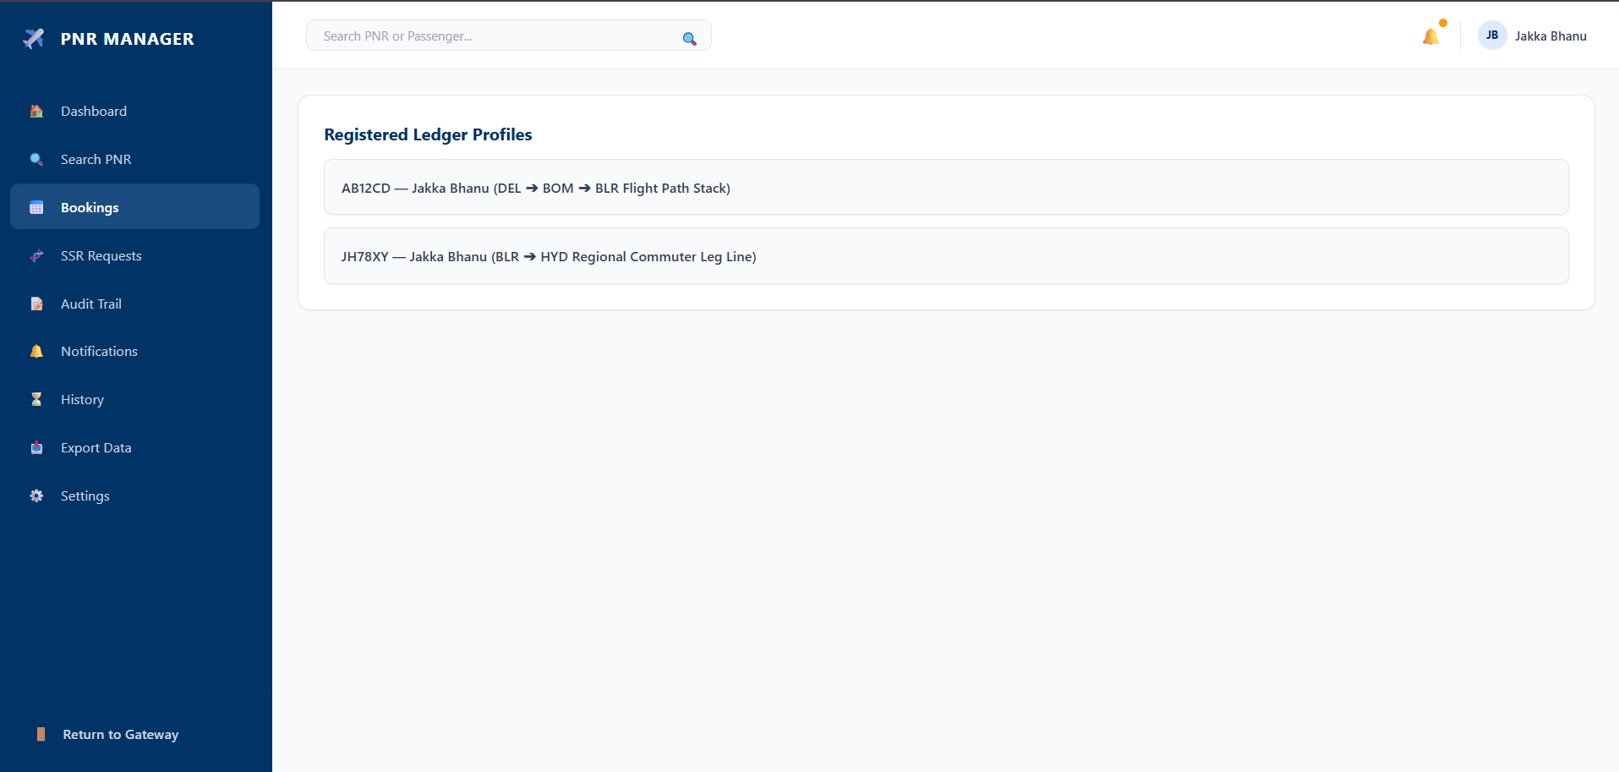
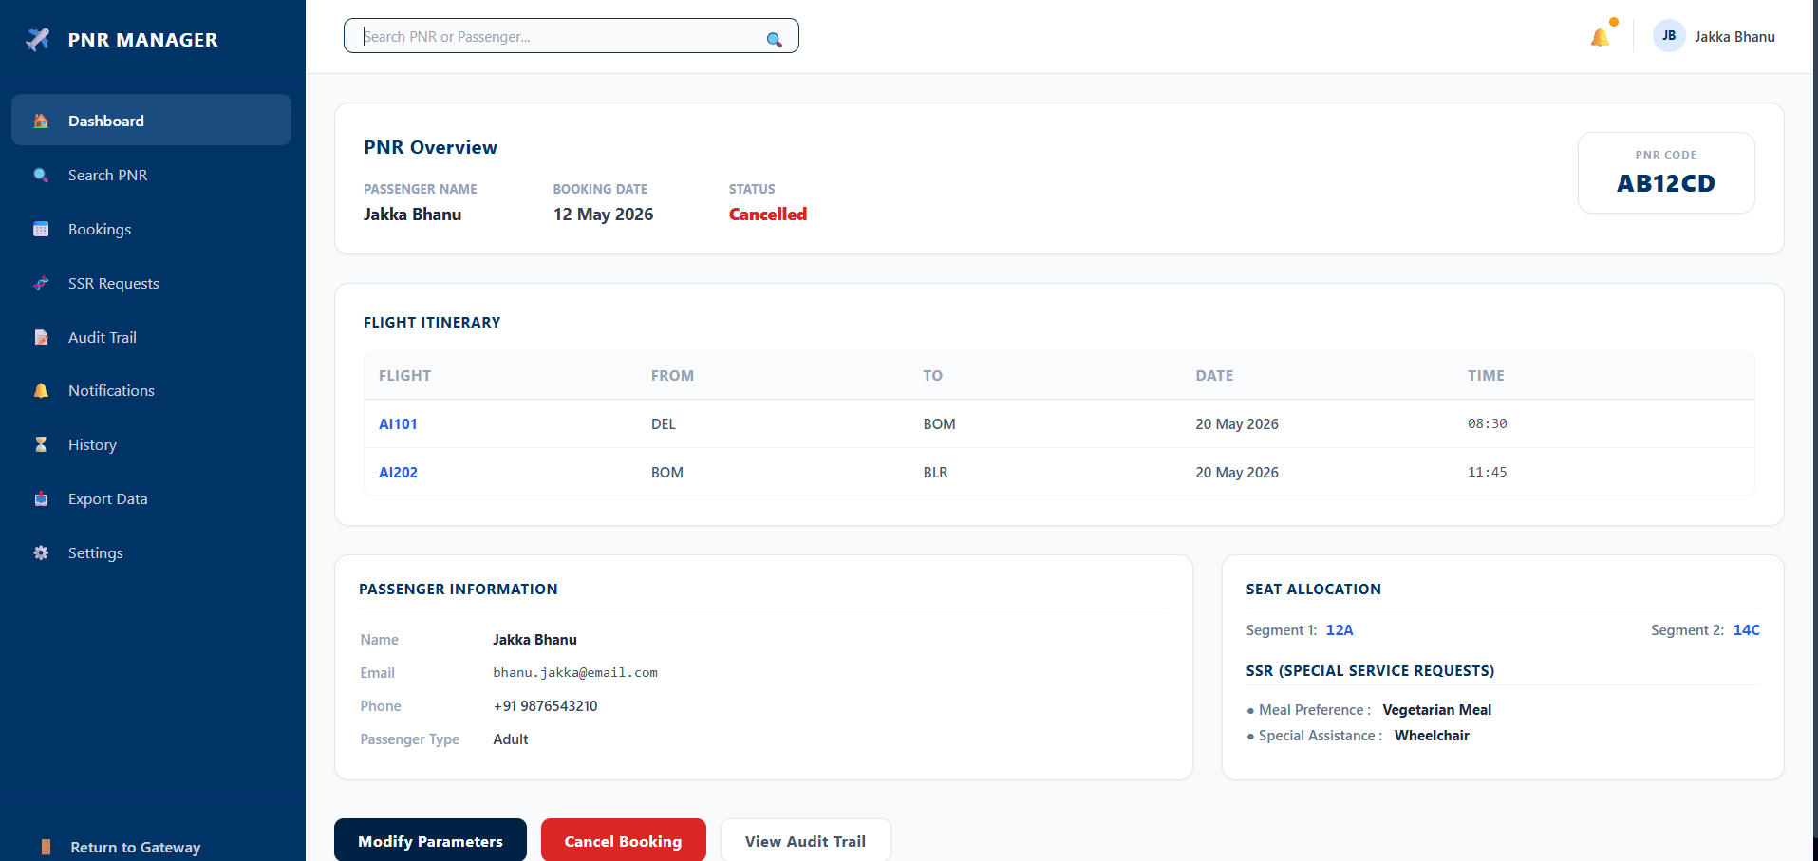
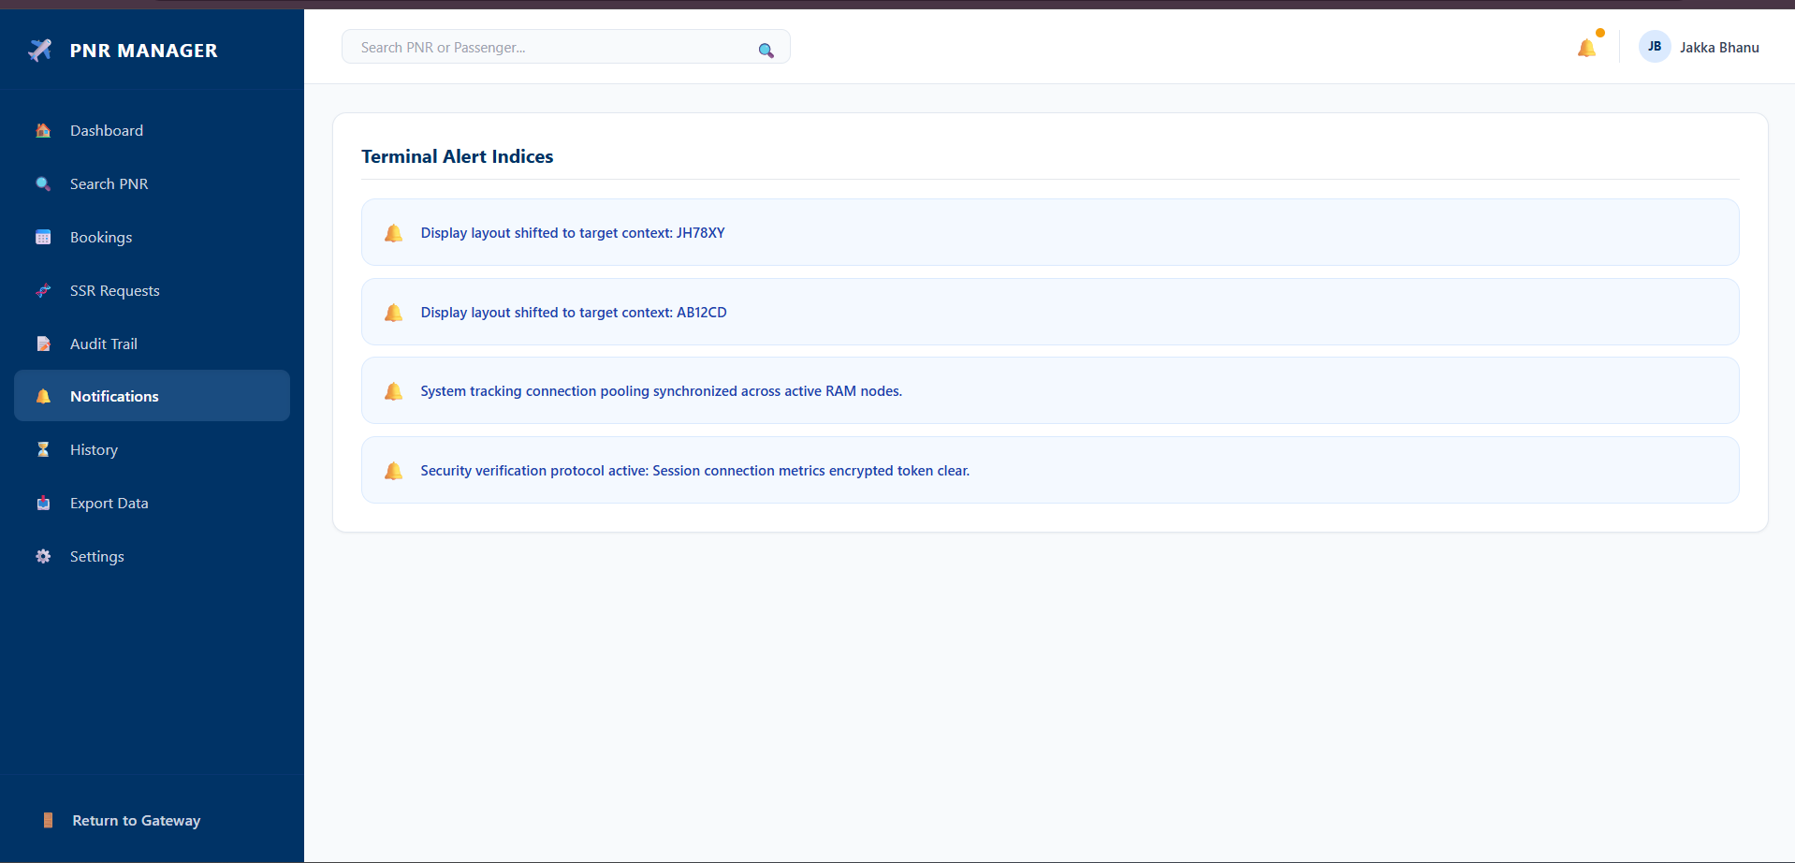

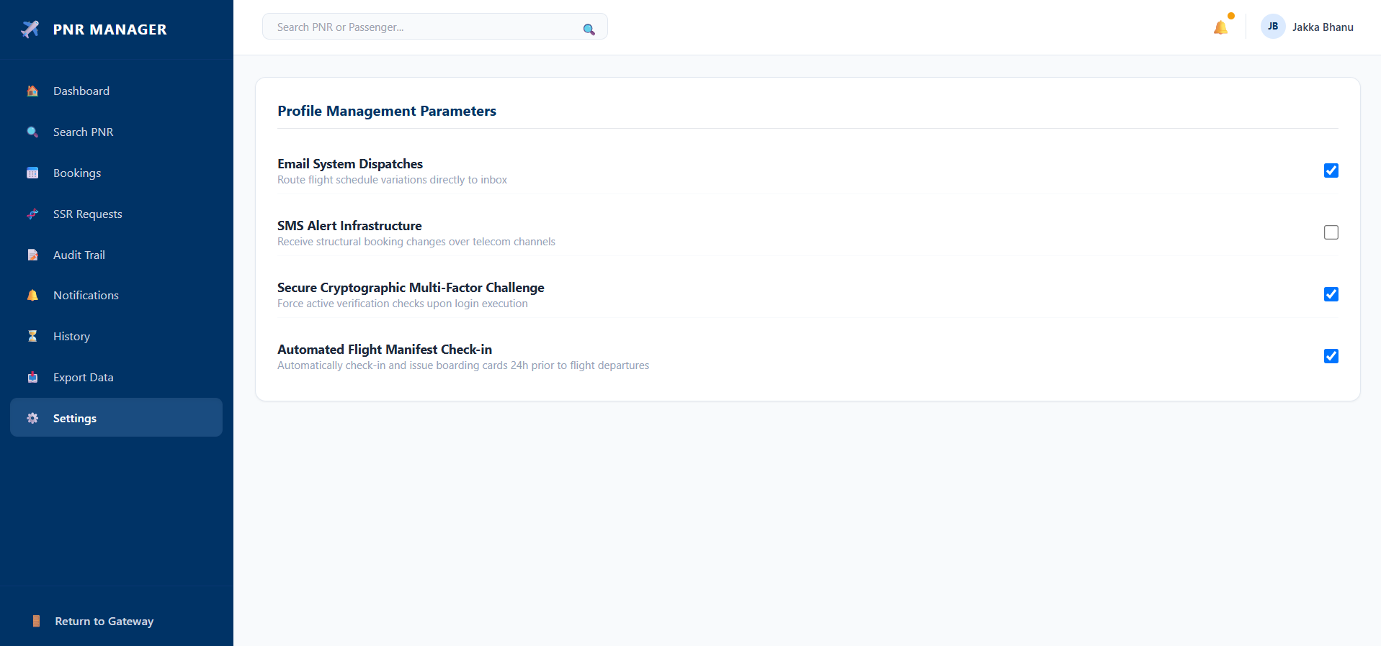

Sample code snippets:

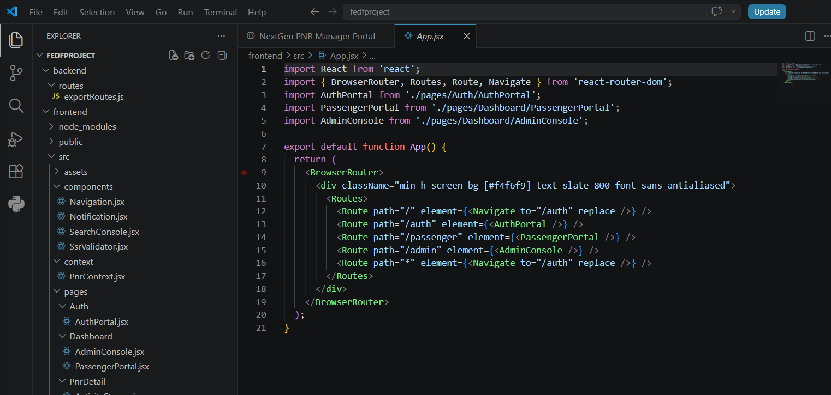
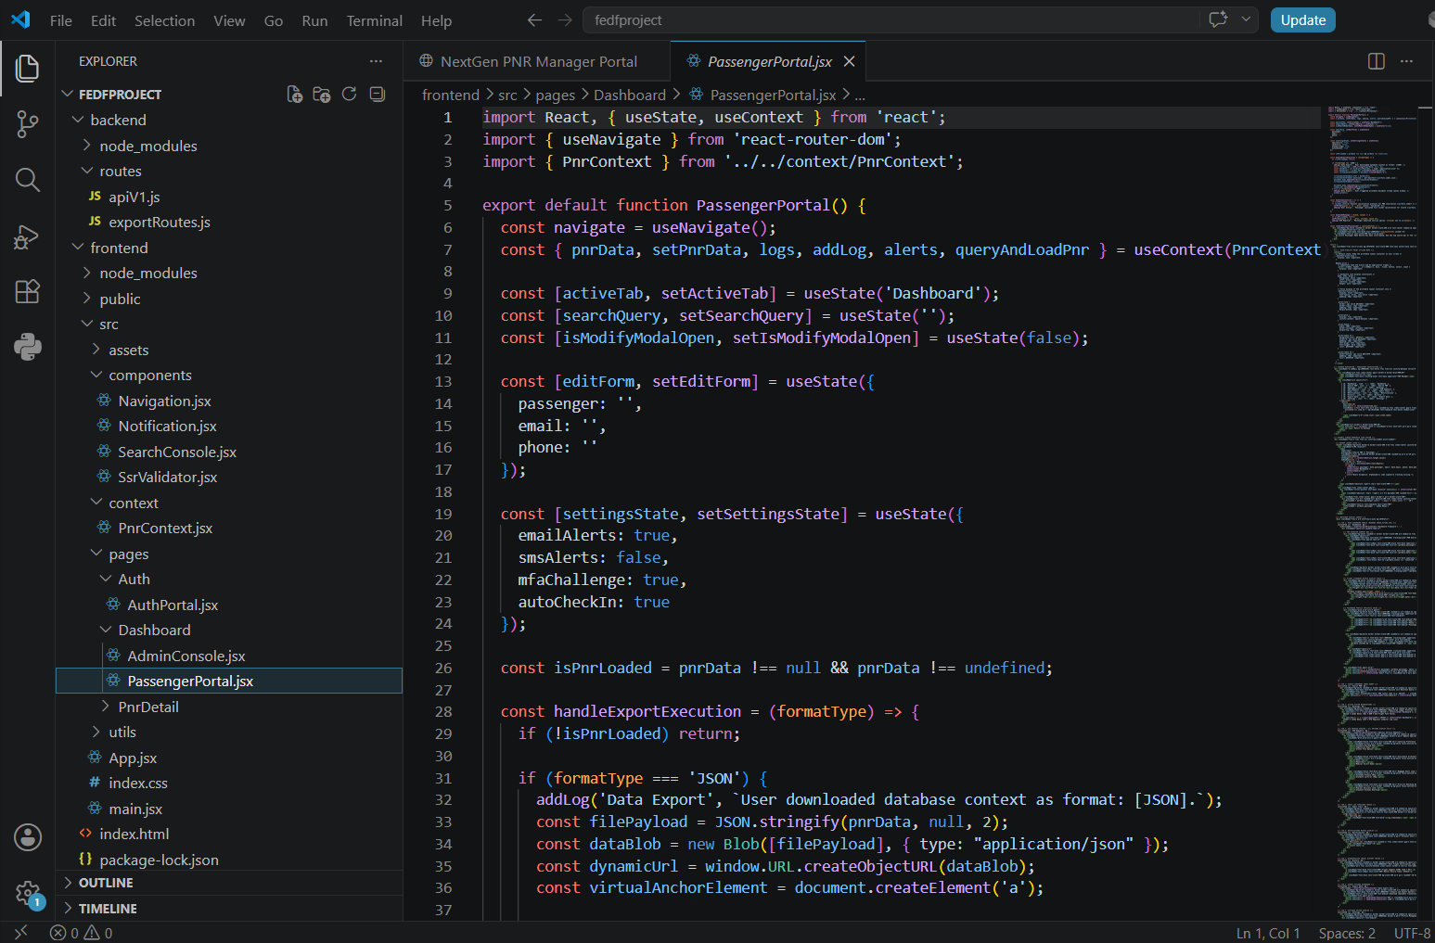
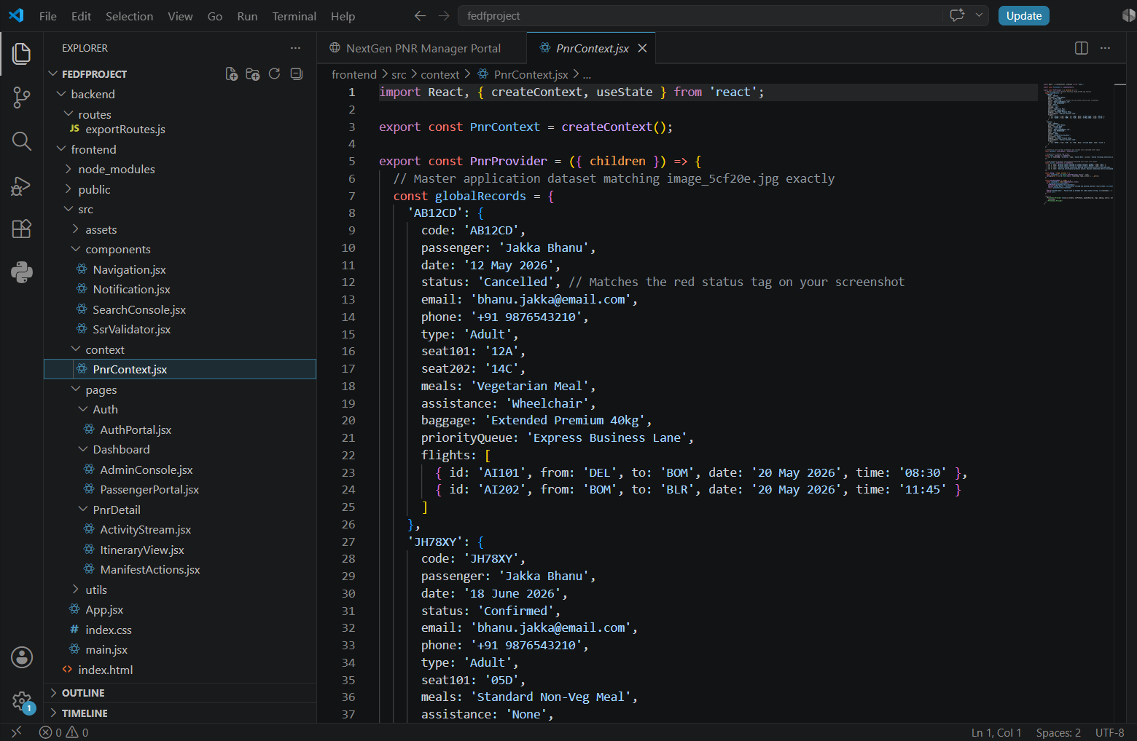
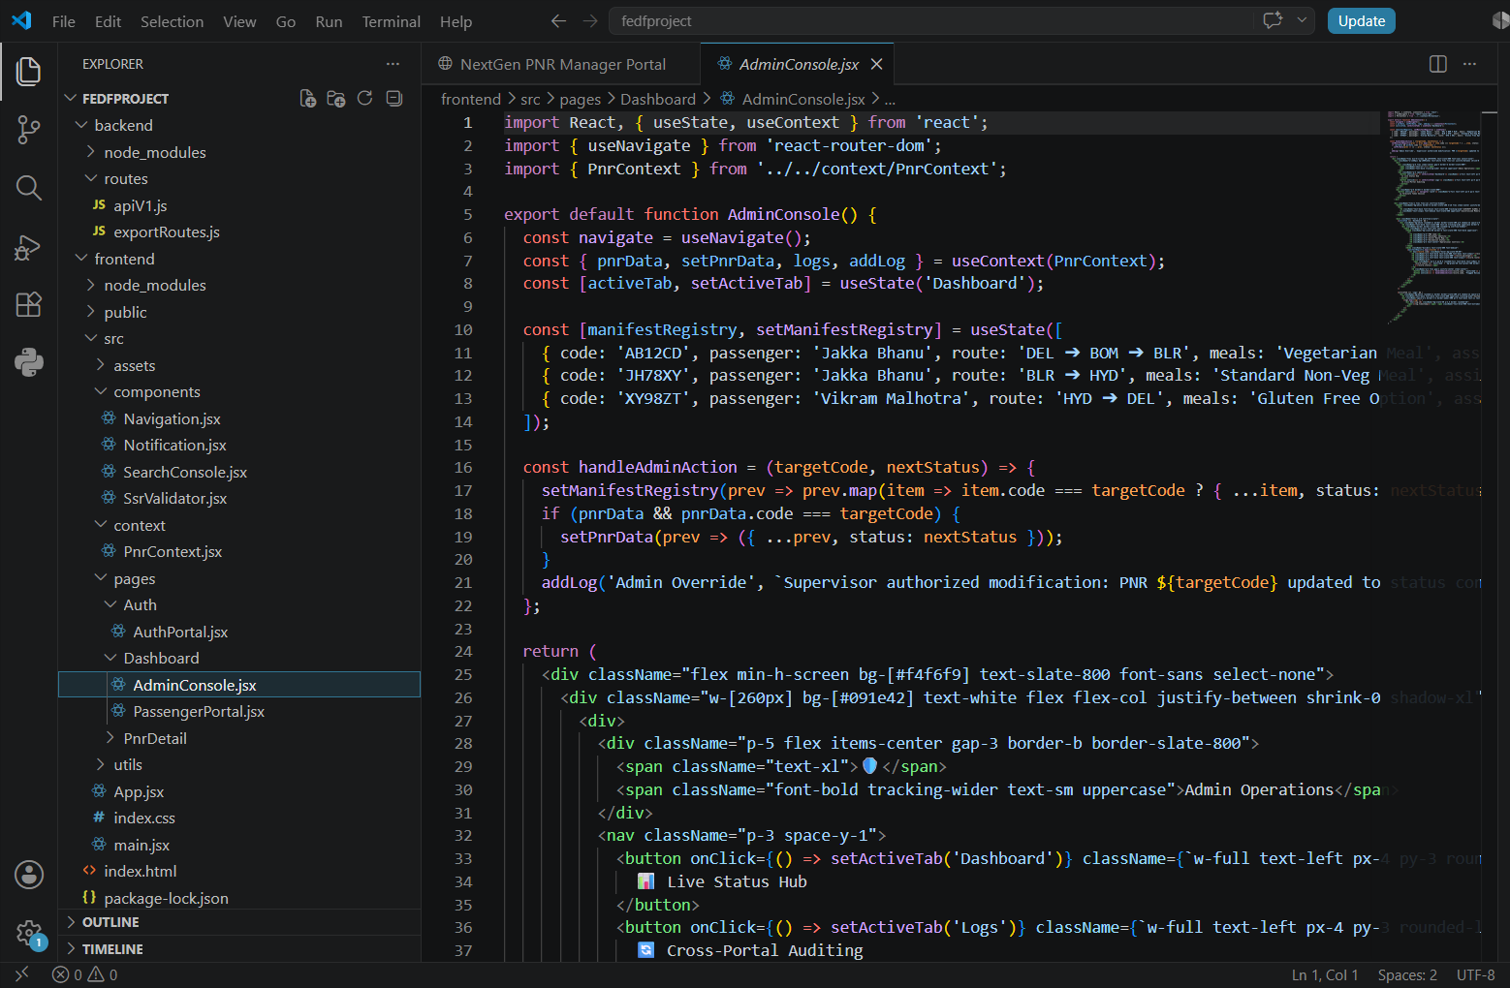

Installation/setup instructions:
The Passenger Name Record Manager project can be run directly in Visual Studio Code. This section provides a detailed 1000-word walkthrough of installation and setup, written in plain text so you can copy it into your documentation without code snippets. It explains the process step by step, covering prerequisites, preparation, dependency installation, environment configuration, database setup, running servers, verification, troubleshooting, and maintenance.

1. Prerequisites:
Before opening the project in Visual Studio Code, make sure the following software is installed on your computer.
Visual Studio Code is the editor where you will run the project. Node.js is required for both frontend and backend, and npm (Node Package Manager) comes bundled with Node.js. MySQL is needed for structured data storage, while MongoDB is required for unstructured data such as special service requests and audit logs. Git is used for version control and repository management.
After installation, confirm that each tool is working by checking its version in the terminal. This ensures that your environment is ready before you begin.

2. Project Preparation:
If the project is hosted on GitHub, download it by cloning the repository. If you have a compressed folder, extract it to a directory of your choice. Open Visual Studio Code and load the project folder.
The project usually contains two main folders: one for the frontend and one for the backend. Each folder must be configured separately.

3. Dependency Installation:
Dependencies are defined in package files. These files list all the libraries and frameworks required to run the project.
Open the terminal in Visual Studio Code. Navigate to the frontend folder and install the dependencies. This will set up React and related libraries. Then navigate to the backend folder and install its dependencies. This will set up Express, database connectors, and other backend libraries.
Installing dependencies ensures that all required packages are downloaded and available for the project to run.

4. Environment Configuration:
Create environment files in both frontend and backend folders. These files store configuration details such as database credentials, server ports, and API addresses.
For the backend, include details such as the port number, MySQL username and password, database name, MongoDB connection string, and a secret key for authentication.
For the frontend, include the API address of the backend server.
Environment variables provide flexibility and security, keeping sensitive data separate from the source code.

5. Database Setup:
The project uses both MySQL and MongoDB.
For MySQL, log in to the server, create a database, and import the schema if provided. This sets up tables and relationships required for bookings and passenger records.
For MongoDB, start the service and create a database. Collections will be created automatically when data is inserted. MongoDB is used for storing unstructured data such as special service requests and audit logs.

6. Running the Backend Server:
Navigate to the backend folder and start the server. The backend runs on the port defined in the environment file. Verify that it is working by visiting the backend address in a browser or by testing endpoints with a tool such as Postman.

7. Running the Frontend Server:
Navigate to the frontend folder and start the React application. The frontend runs on a default port and communicates with the backend through the API address defined in the environment file. Open the frontend address in a browser to access the application.

8. Troubleshooting:
Common issues may occur during setup.
If npm is not recognized, ensure that Node.js is installed and added to the system path. If database connection errors occur, verify credentials in the environment files and ensure that services are running. If the frontend does not load, check that the backend is running and that the API address is correct. If ports are in conflict, change them in the environment files. If dependencies are missing, reinstall them.

9. Maintenance:
Keep the system updated by regularly updating dependencies. Backup databases periodically to prevent data loss. Document configuration changes for future reference. Use Git for version control, committing changes regularly to maintain a history of updates.

10. Conclusion:
Installation and setup of the Passenger Name Record Manager project in Visual Studio Code involves preparing prerequisites, downloading the project, installing dependencies, configuring environment variables, setting up databases, running servers, verifying integration, troubleshooting issues, and maintaining the system. Following these steps ensures that the project runs smoothly in a local environment, providing a reliable platform for managing passenger records.

User manual or guide
The Passenger Name Record Manager is a system built to simplify airline booking management by combining a React-based frontend, a Node.js and Express backend, and databases using MySQL and MongoDB. The project was designed to serve passengers, staff, and administrators, each with distinct needs. Passengers can manage bookings and requests, staff can handle operational workflows, and administrators can oversee reporting and audit trails. Its modular design ensures that every function, from searching records to exporting data, is organized and accessible.
To install and set up the system, users begin by preparing their environment with Visual Studio Code, Node.js, MySQL, MongoDB, and Git. Once the project is downloaded or cloned, dependencies are installed separately for the frontend and backend. Environment files are then created to store configuration details such as database credentials, server ports, and API addresses. Databases are initialized, with MySQL handling structured booking data and MongoDB storing unstructured information like special service requests. This preparation ensures the system is ready to run locally.
Running the system involves starting the backend server, which manages API requests and business logic, and then launching the frontend server, which provides the user interface. The frontend communicates with the backend through the API address defined in the environment configuration. Once both servers are active, the application can be accessed in a browser, allowing users to interact with modules such as dashboard, bookings, notifications, and history. Verification of workflows, such as creating bookings and submitting requests, confirms that integration between frontend, backend, and databases is functioning correctly.
Troubleshooting focuses on common issues like missing dependencies, incorrect database credentials, or port conflicts. Solutions include reinstalling Node.js if npm is not recognized, checking environment files for accurate credentials, ensuring backend services are running before launching the frontend, and adjusting port numbers when conflicts occur. Maintenance practices include updating dependencies, backing up databases, documenting configuration changes, and using Git for version control. These steps keep the system secure, reliable, and efficient over time.

